**console.log(a); Practice programs**

**1.Passing a number as an argument**

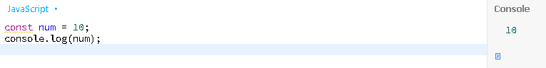

**2. Passing a string as an argument**

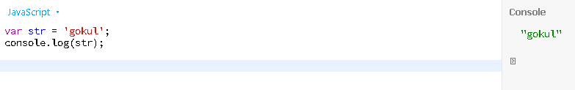

**3.Passing a char as an argument**

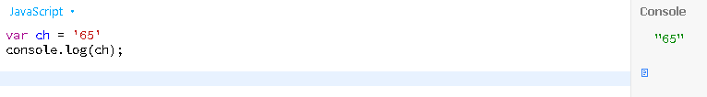

**4. Passing a message as an argument**

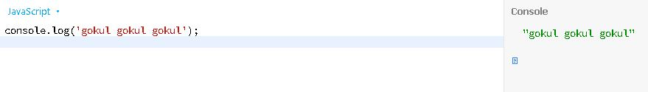

**5.Passing a function as an argument**

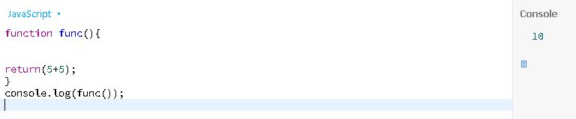

**6.Passing a number with message as an argument**

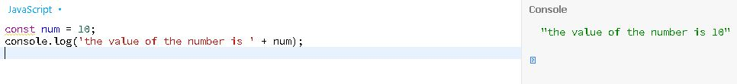

**7. Passing a string with message as an argument**

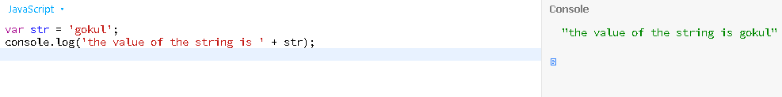

**8.Passing a char with message as an argument**

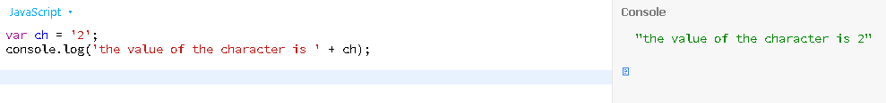

**9.Number count**

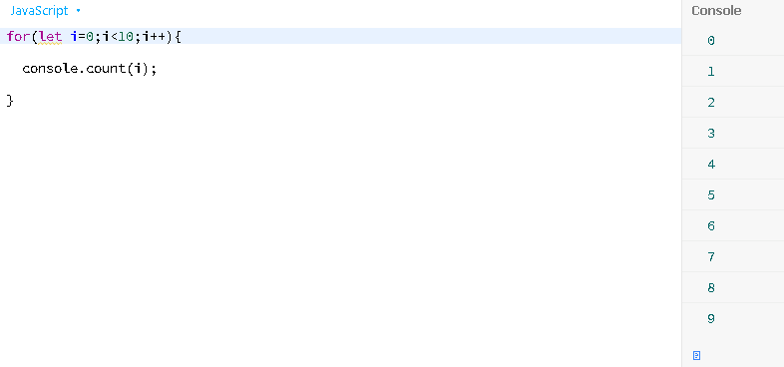

**10.Check whether an input is a string or not**

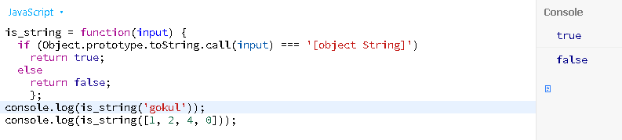

**11.Check blank string or not**

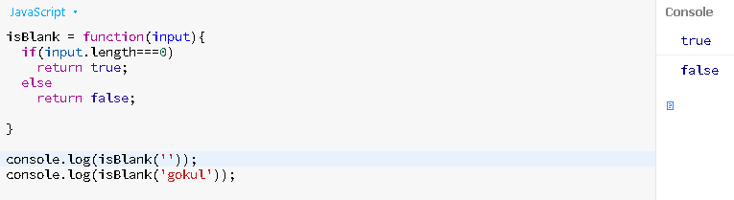

**12.Reverse a number**

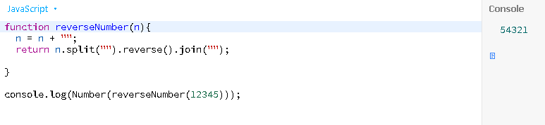

**13.string to array of strings**

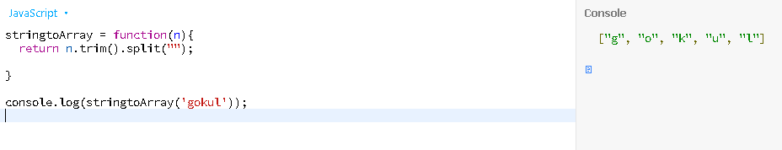

**14. Extract a specific number of characters from a string**

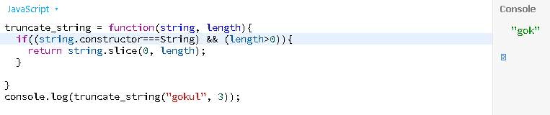

**15.Convert a string in abbreviated form**

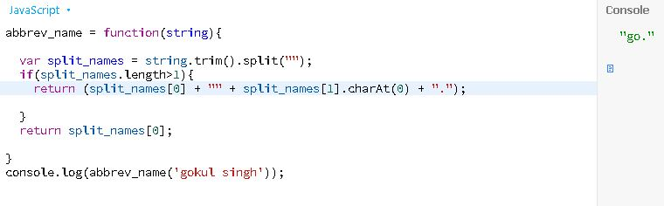

**16.Parameterize a string**

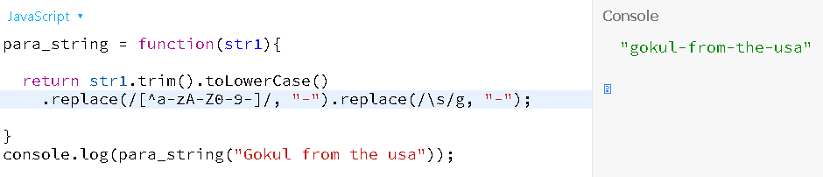

**17.Make capitalize the first letter of a string**

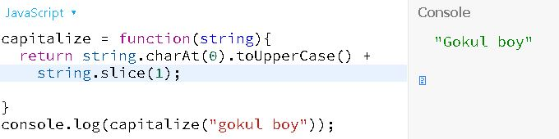

**18.Make capitalize the first letter of each word in a string**

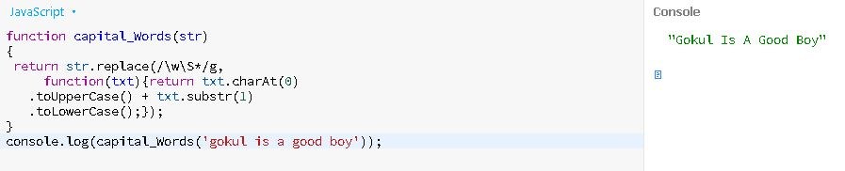

**19. Input a string and converts upper case letters to lower and vice versa**

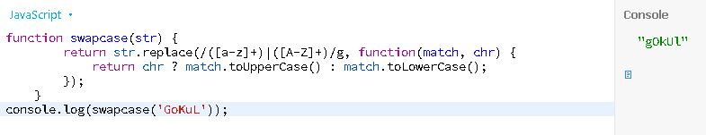

**20. Convert a string into camel case**

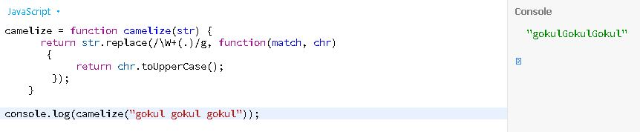

**21.Make a string uncamelize**

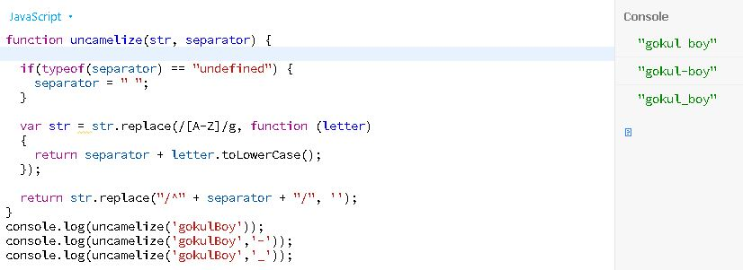

**22. Find the highest value in an array**

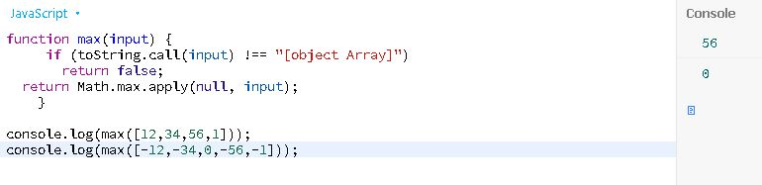

**23.Positive negative**

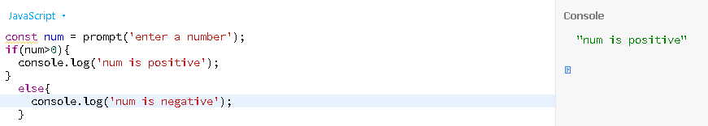

**24.Greater less than**

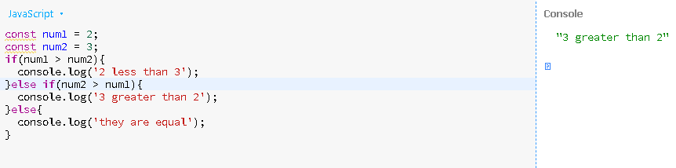

**25.Lowest array**

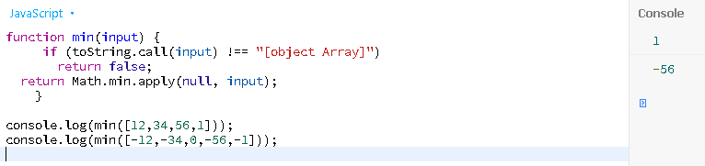

**26. Calculate the sum of values in an array**

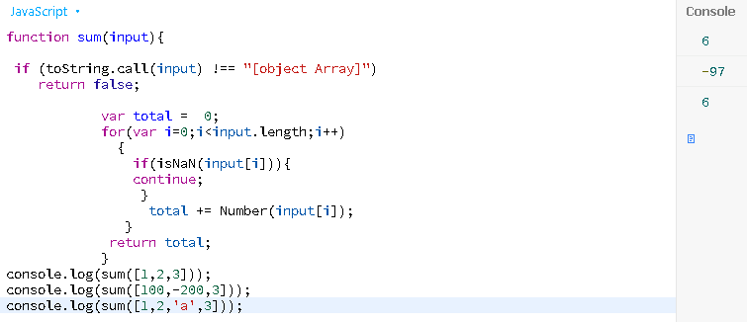

**27. Calculate the product of values in an array**

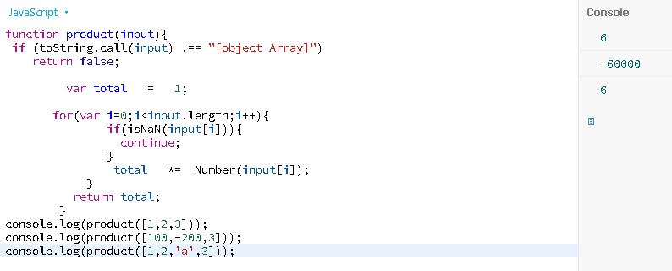

**28.Convert a positive number to negative number**

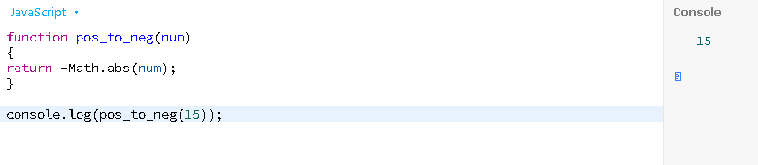

**29.Get the highest number from three different numbers**

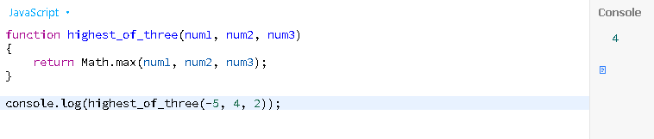

**30.Calculate the percentage of a number**

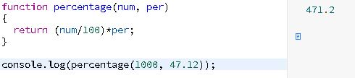

**31.Clone an array**

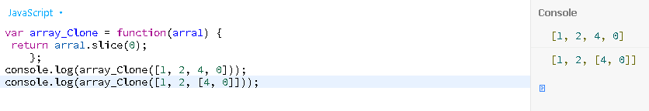

**32. Get the first element of an array**

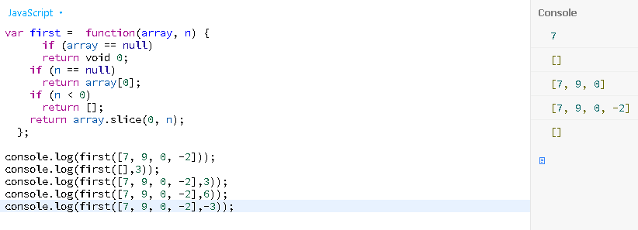

**33.Get the last element of an array**

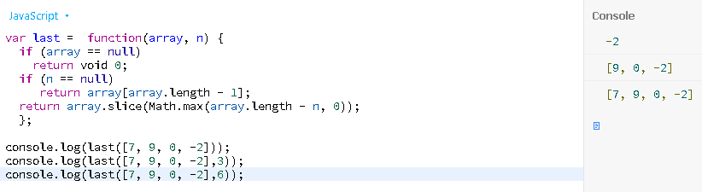

**34. Join all elements of an array into a string**

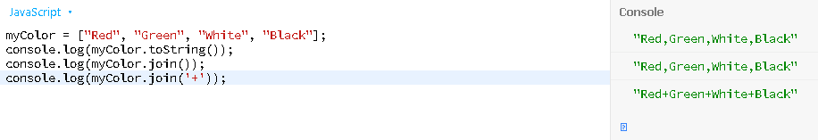

**35. Swap the case of each character of a string, upper case to lower and vice versa**

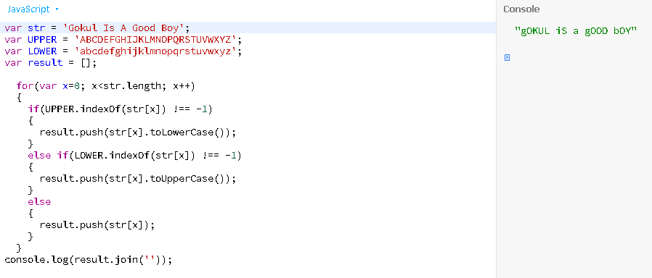

**36.Compute the sum and product of an array of integers**

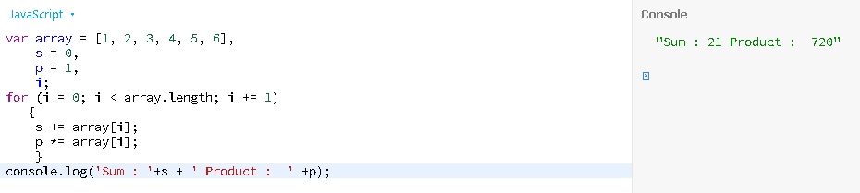

**37.Remove a specific element from an array**

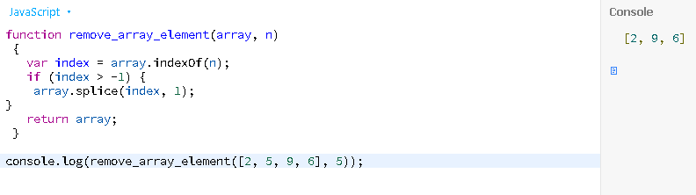

**38.Find if an array contains a specific element**

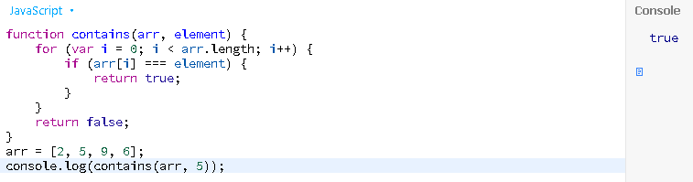

**39. Empty an array keeping the original**

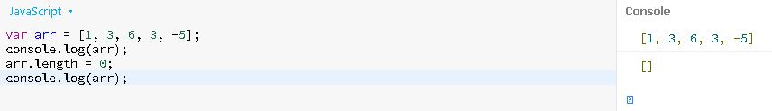

**40.Get a random item from an array**

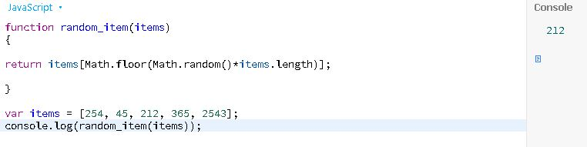

**41.Accept two integers and display the larger**

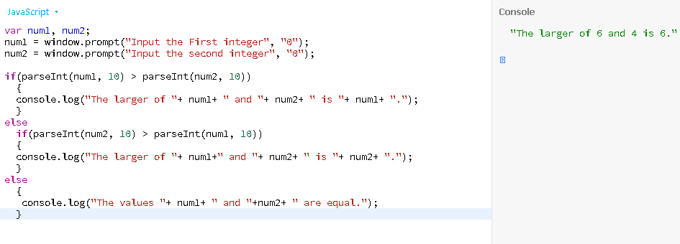

**42. Find the sign of product of three numbers**

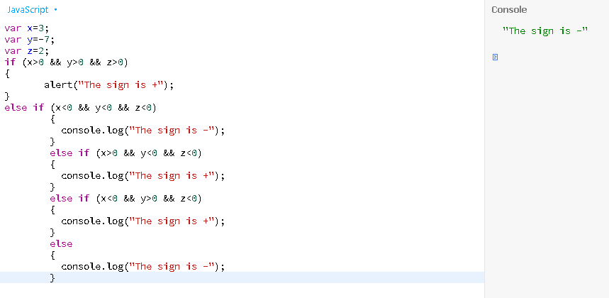

**43.How to sort three numbers**

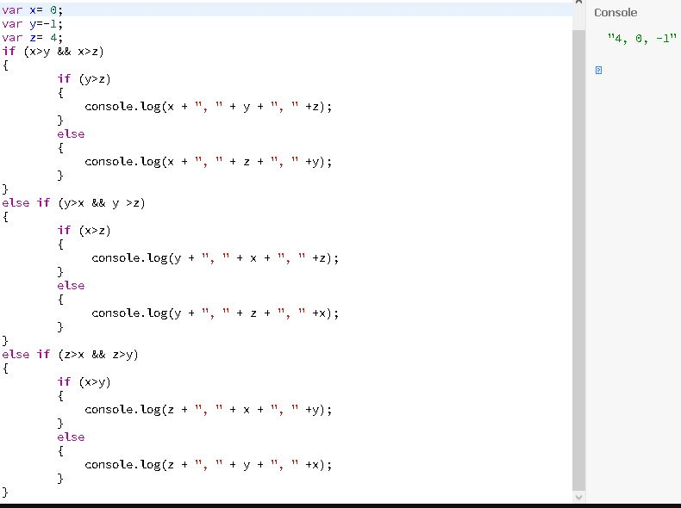

**44.Find the largest of five numbers**

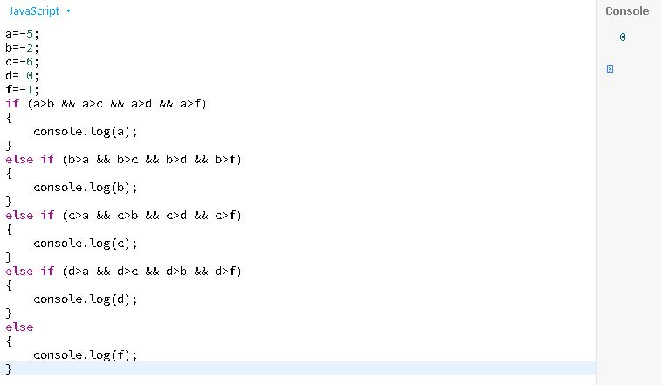

**45.Construct a pattern, using a nested for loop**

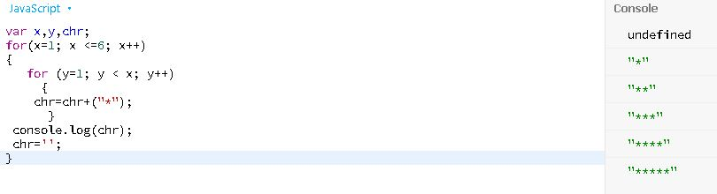

**46. Get the integers in a range**

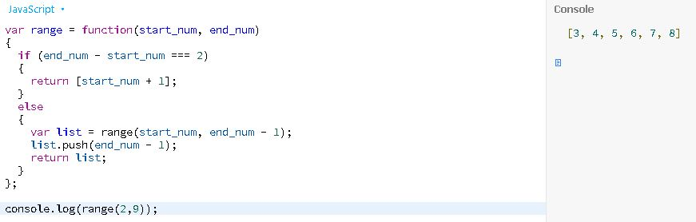

**47.Compute the sum of an array of integers**

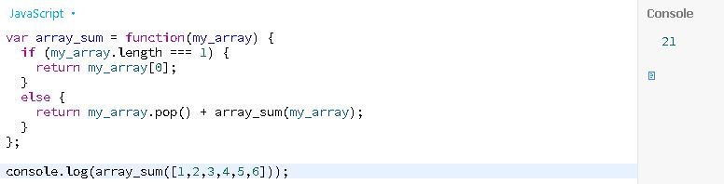

**48.Get the first n Fibonacci numbers**

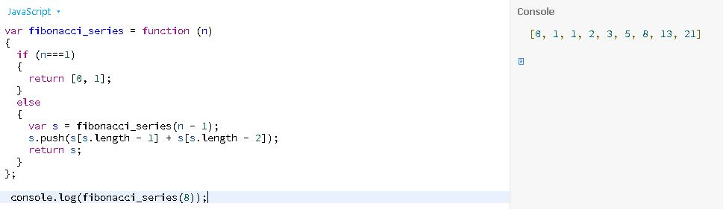

**49.Check whether a number is even or not**

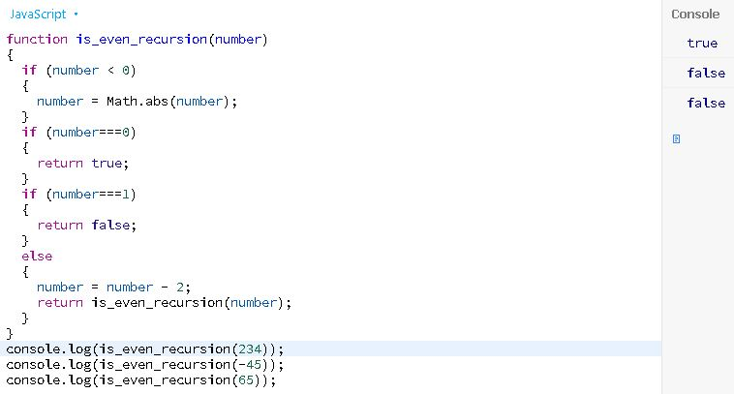

**50.Reverse the order of the characters in the string**

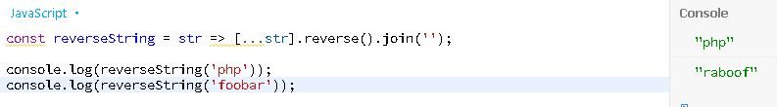

**51.Check whether the first character of a string is uppercase or not**

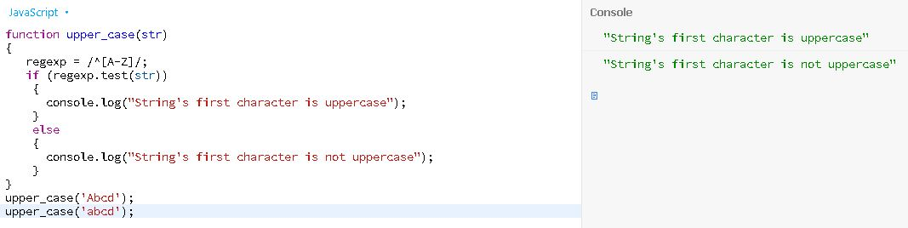

**52.Check a credit card number format**

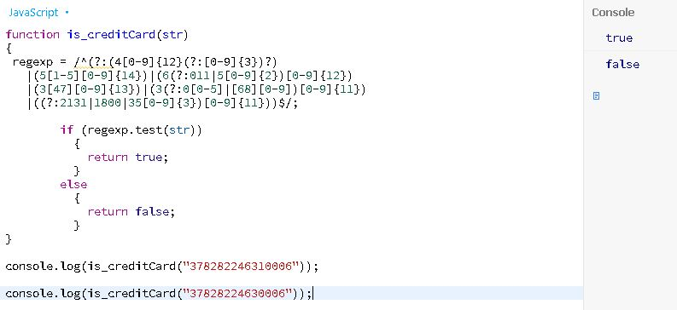

**53.Check whether the pattern of an e-mail address matches a specific format**

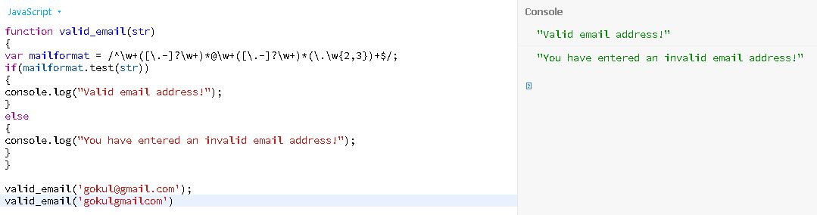

**54.Simple greet**

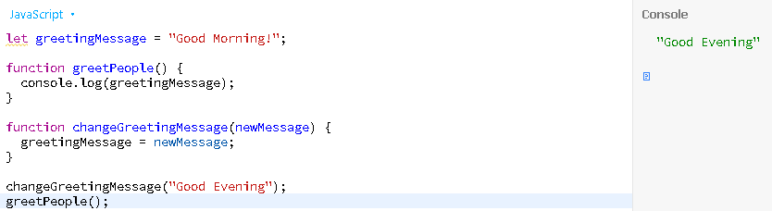

**55.Simple arithmetic**

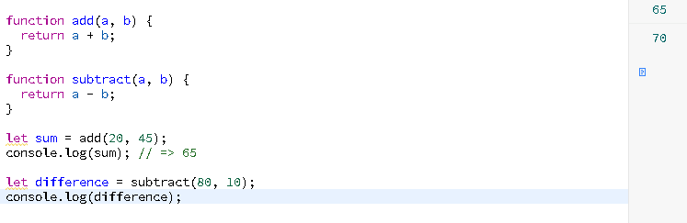

**56.Simple prompt arithmetic**

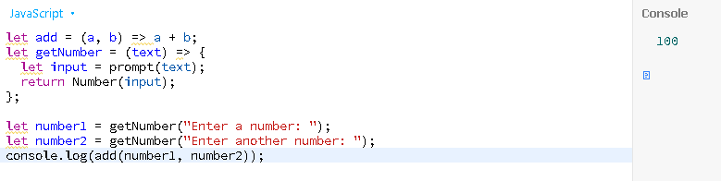

**57.Simple swap**

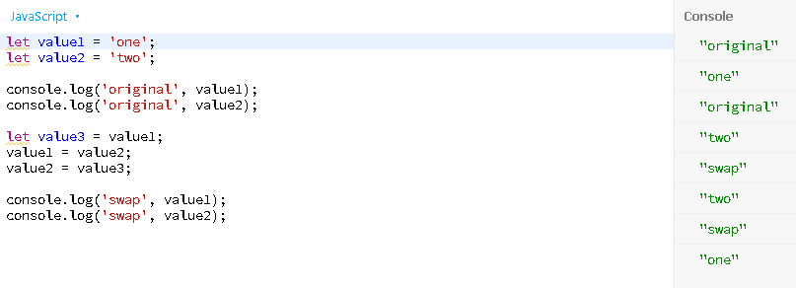

**58.Max number**

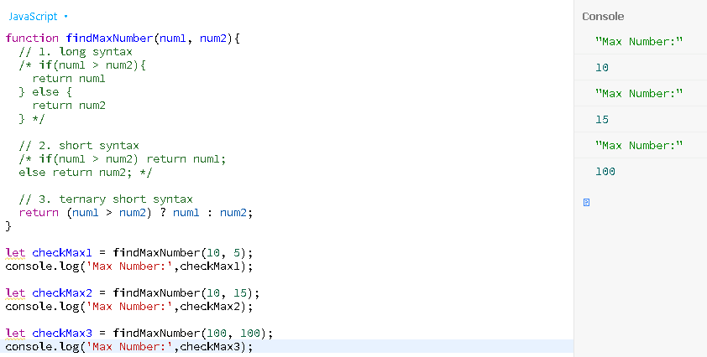

**59.Landscape Portrait**

https://paper-attachments.dropbox.com/s_C5B659B26D40BB65B2DE8961BD79883144D53D1BAFD5EA39A61C86C458237F8F_1632901210826_image_2021-09-29_131010.png

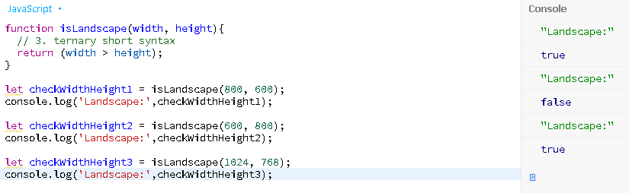

**60. FizzBuzz Algorithms**

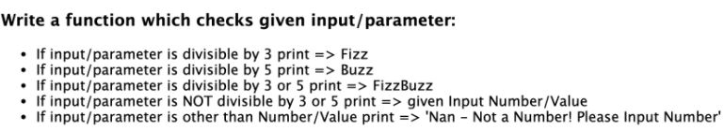

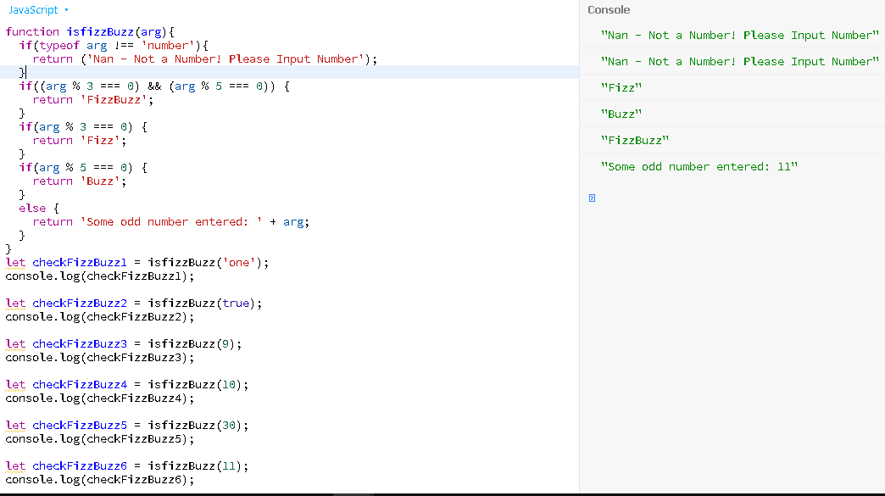

**61. Speed Limits**

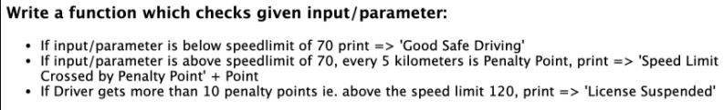

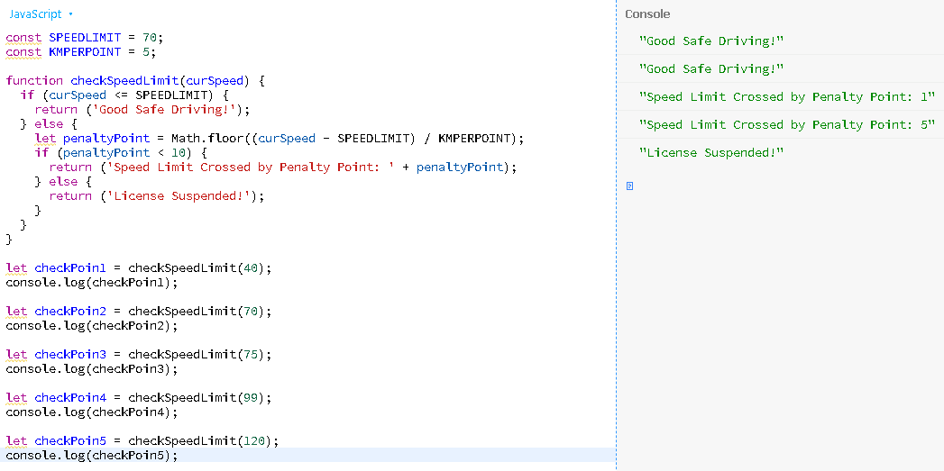

**62.Odd Even Number Loop**

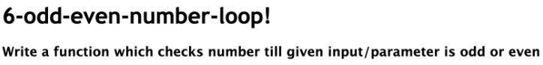

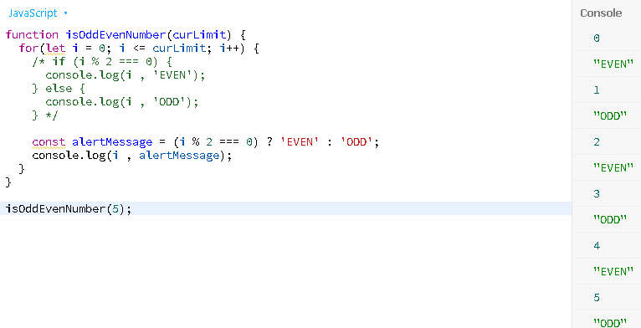

**63. Count Truthy Falsy Values**

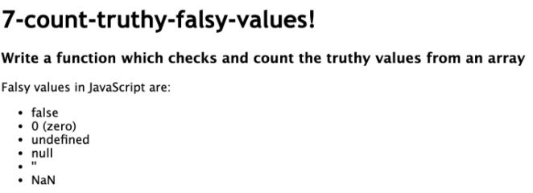

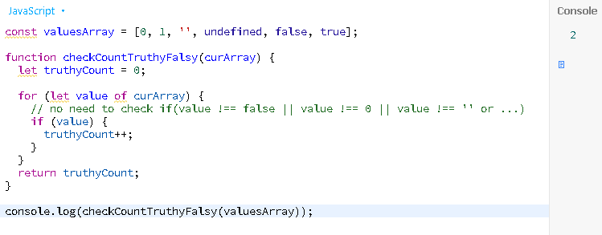

**64.Object String Properties Key**

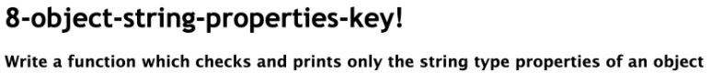

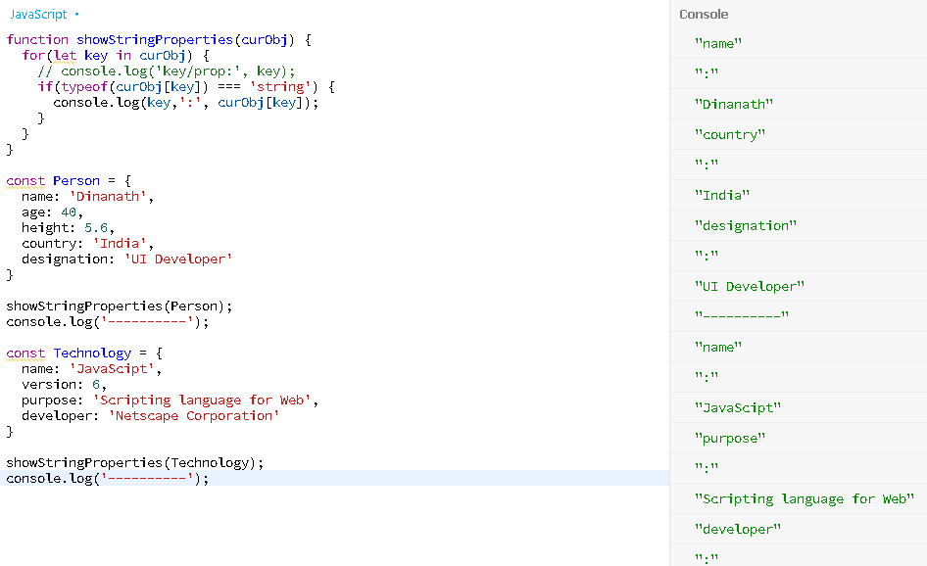

**65. Sum of Multiples**

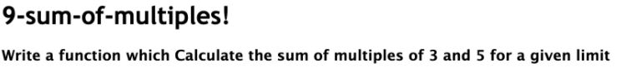

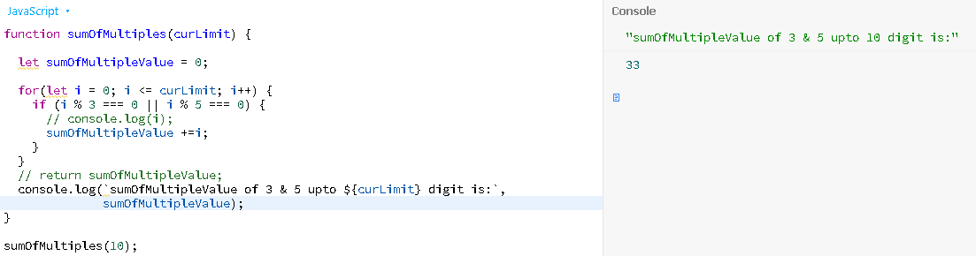

**66.Netsted Loop Star Pattern**

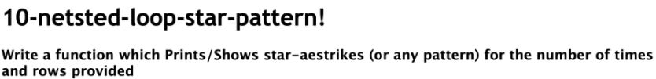

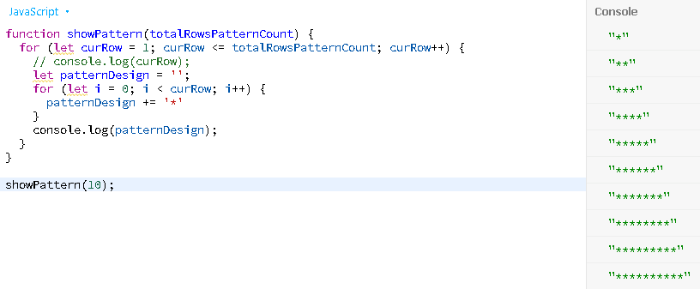

**67. Marks Average Grade**

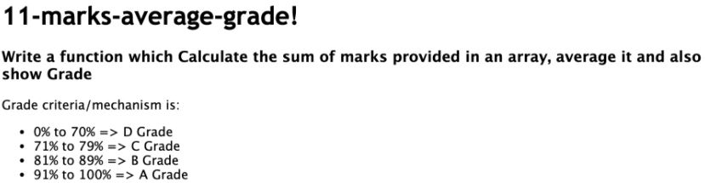

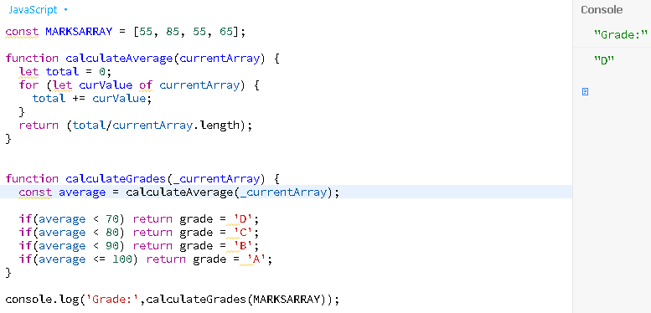

**68. Show Prime Numbers**

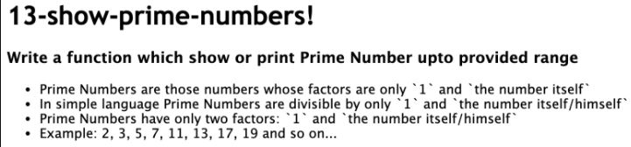

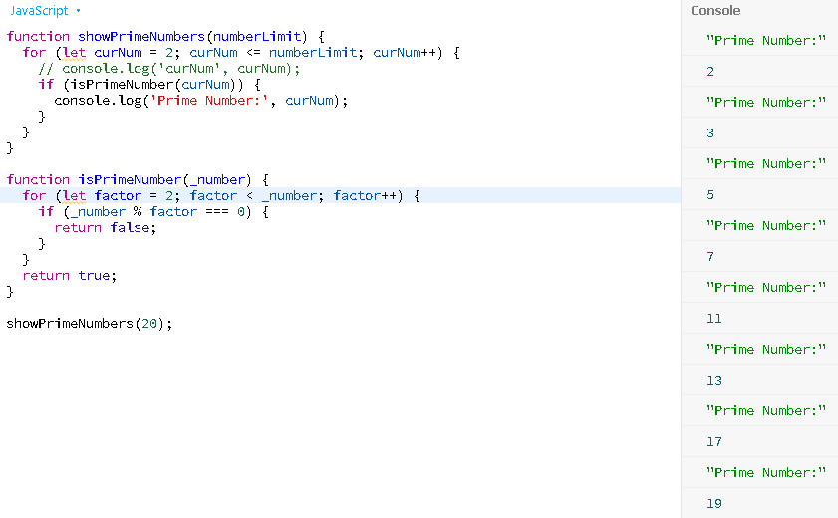

**69.Sum Of Arguments**

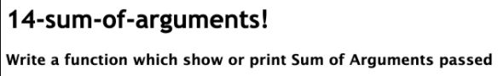

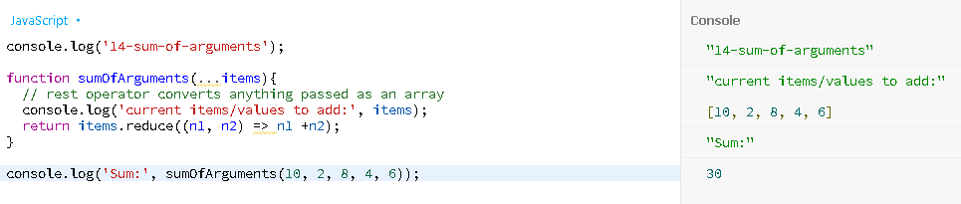

**70.Sum Of Arguments Array**

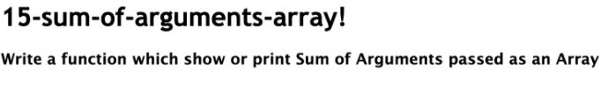

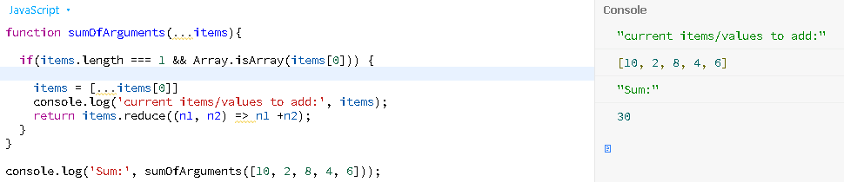

**71.Circle Area Object Read Only Property**

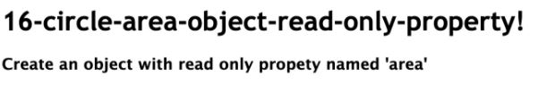

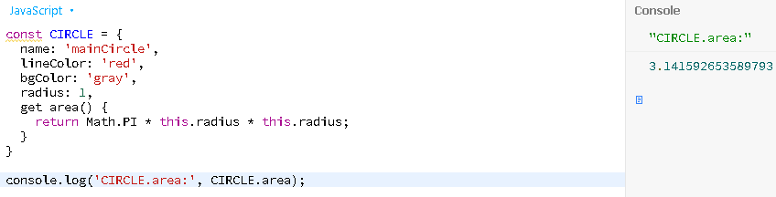

**72.Create Array From Argument Range**

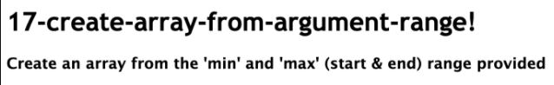

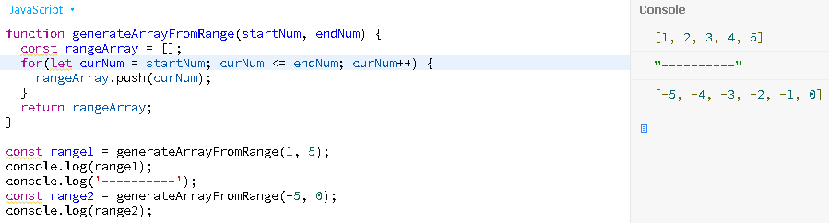

**73.Array Includes Element Exists**

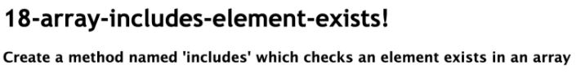

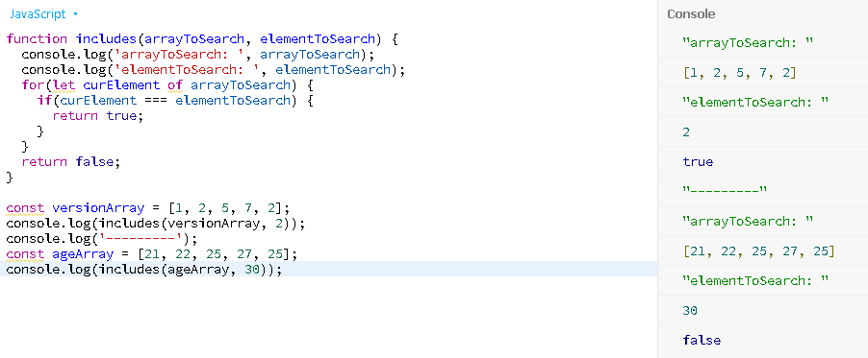

**74.Array Excludes Value To New Array**

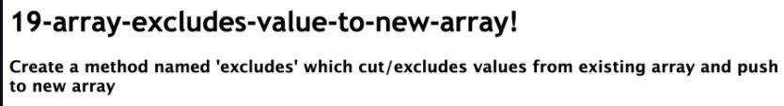

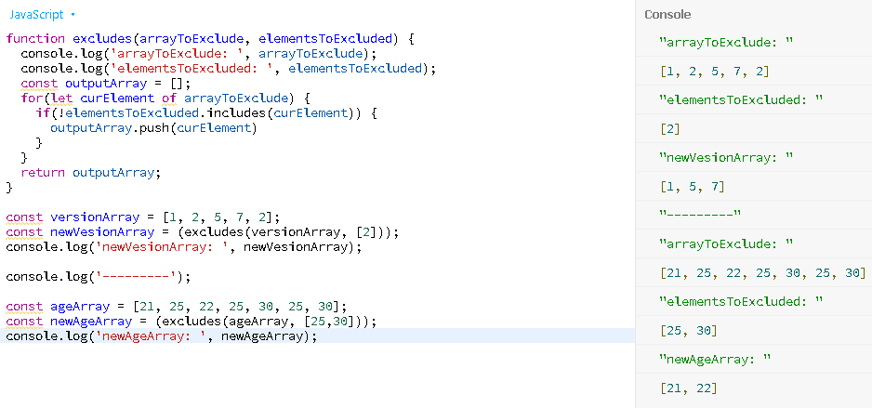

**75.Array Count Search Occurances**

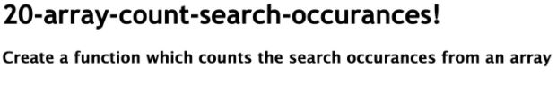

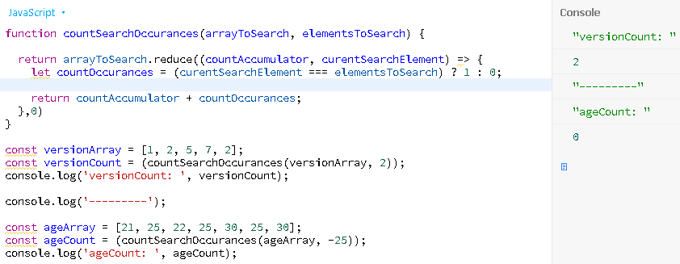

**76.Array Get Max Largest Number**

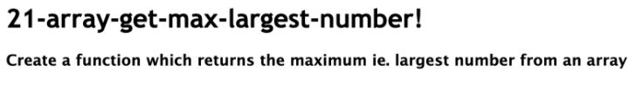

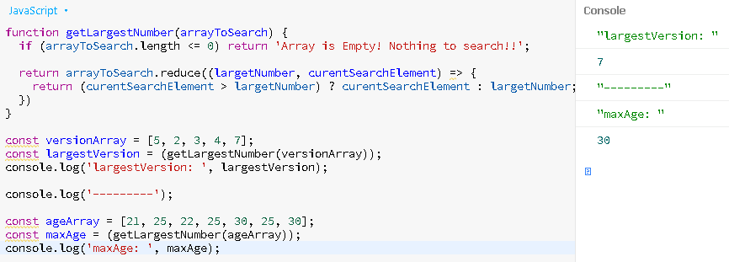

**77.Array Filter Sort Map**

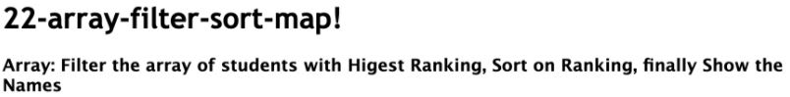

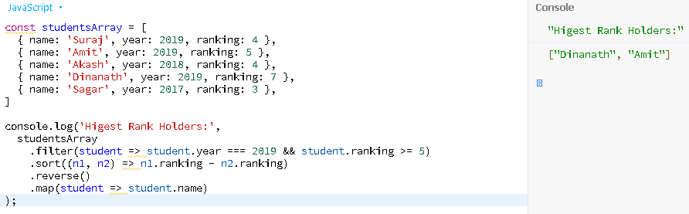

**78.Object Create Students and Address Object**

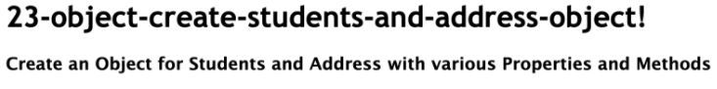

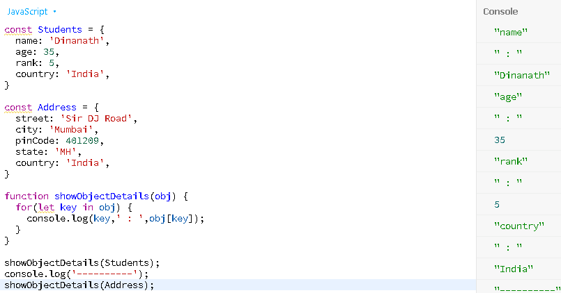

**79.Object Create Object Factory Constructor Function**

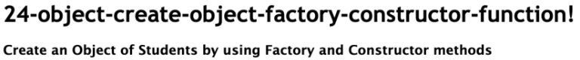

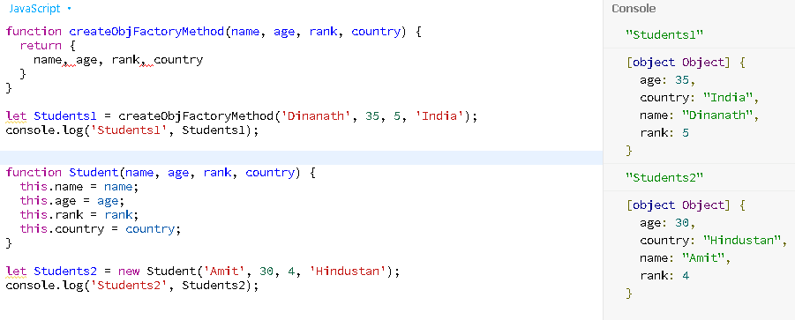

**80.Object Equality**

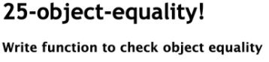

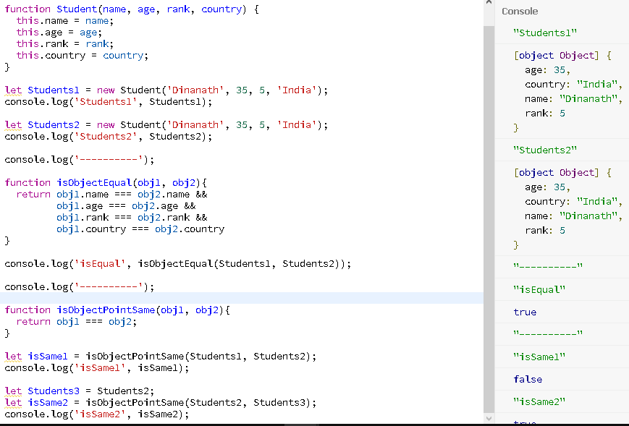

**81.forofloop**

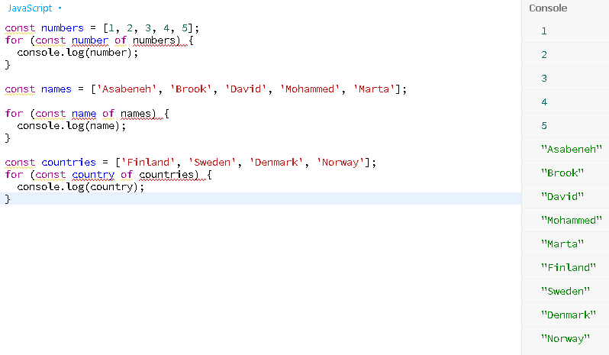

**82.Simple Addition**

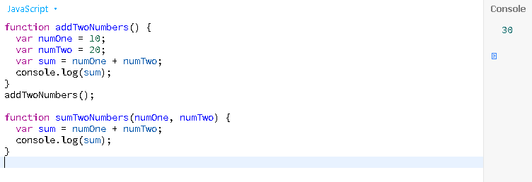

**83.sumOfEvensAndOdds**

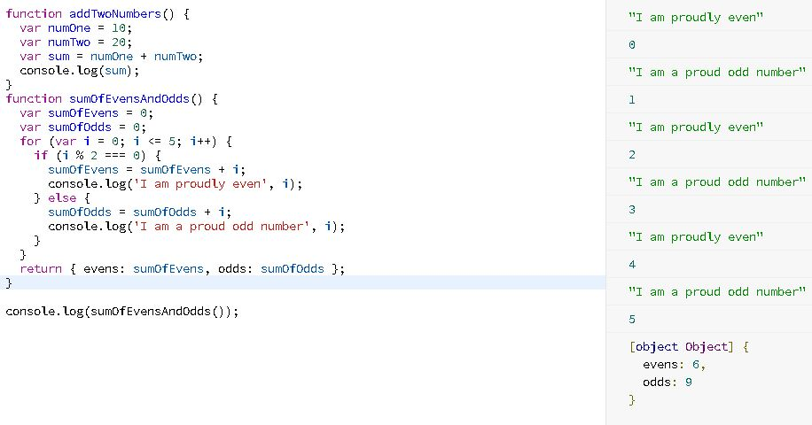

**84.do….while loop**

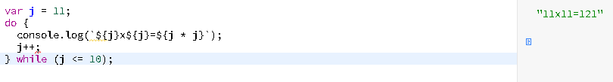

**85.while loop**

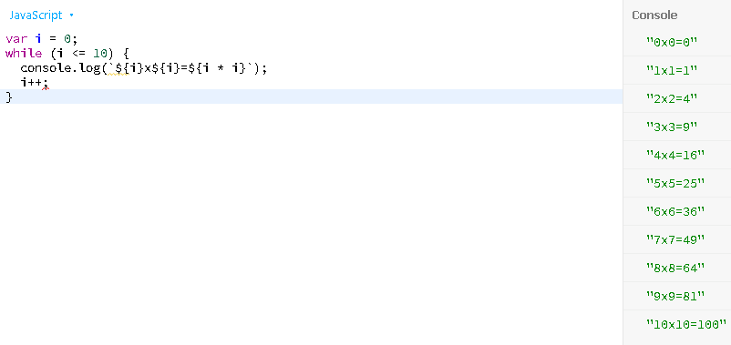

**86.for…loop**

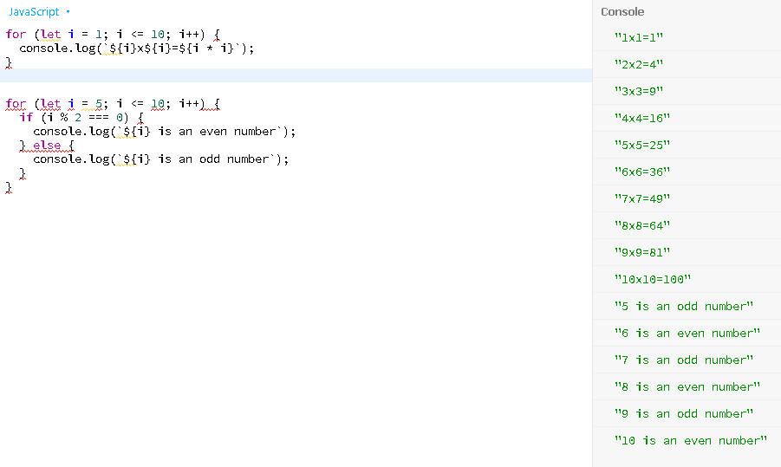

**87.slice(), splice(“”)**

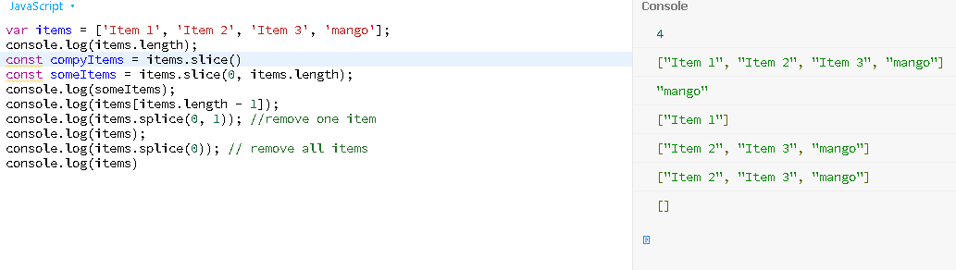

**88.Ternary operator**

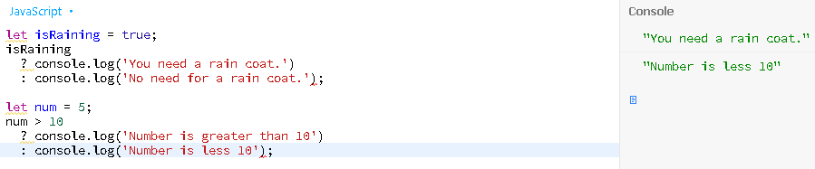

**89.switch case**

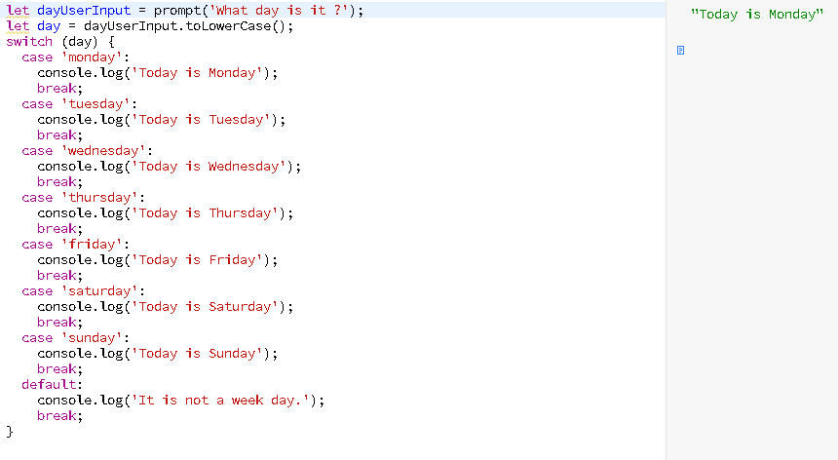

**90.If…else if….else**

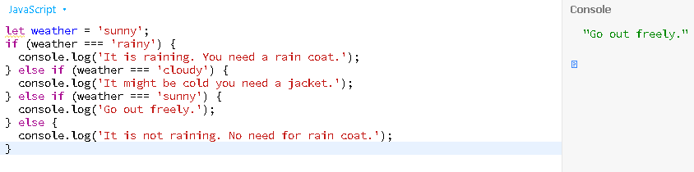

**91.Min numbers**

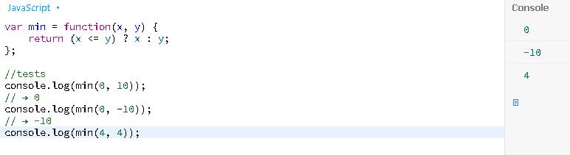

92.Recursion

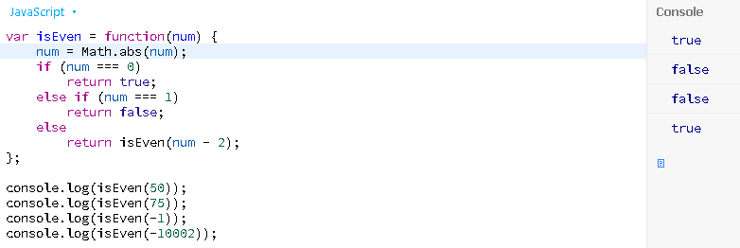

**93.Array filter**

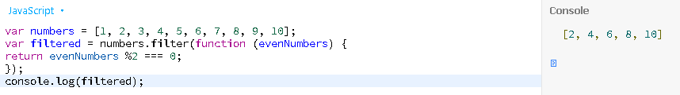

**94.Math.round()**

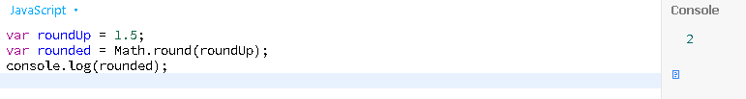

**95.Objects**

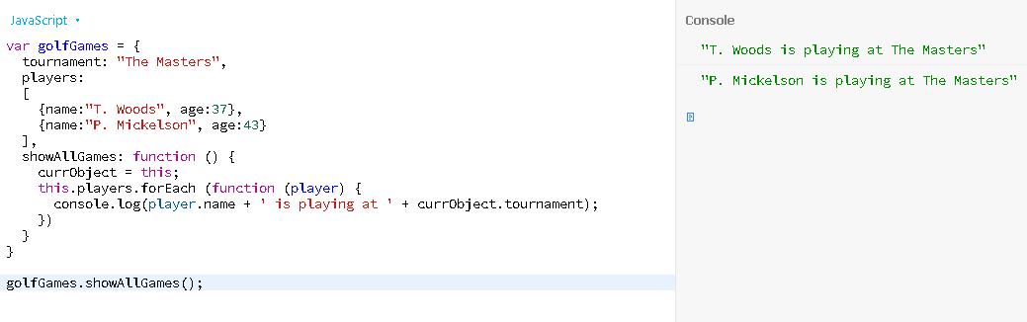

**96.Callback()**

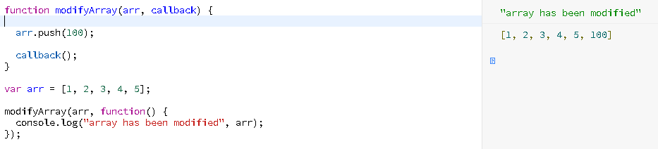

**97.Concatenation**

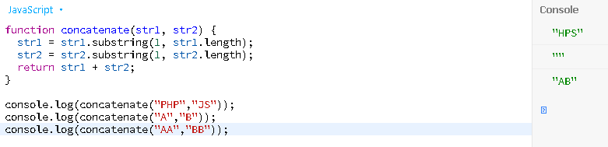

**98.Slice()**

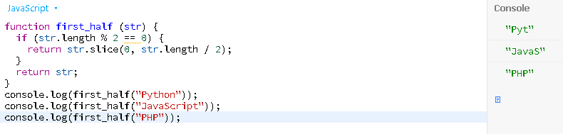

**99.Move last three character to the start of a specified string**

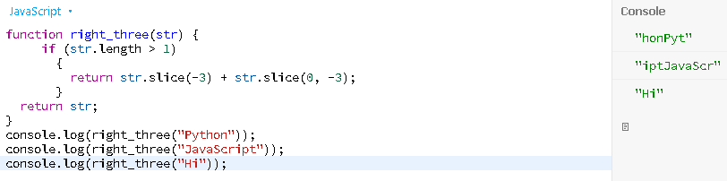

**100. Create a string using the middle three characters of a given string of odd length**

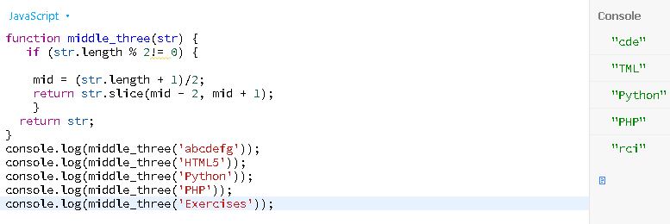

**101.Find the anagrams**

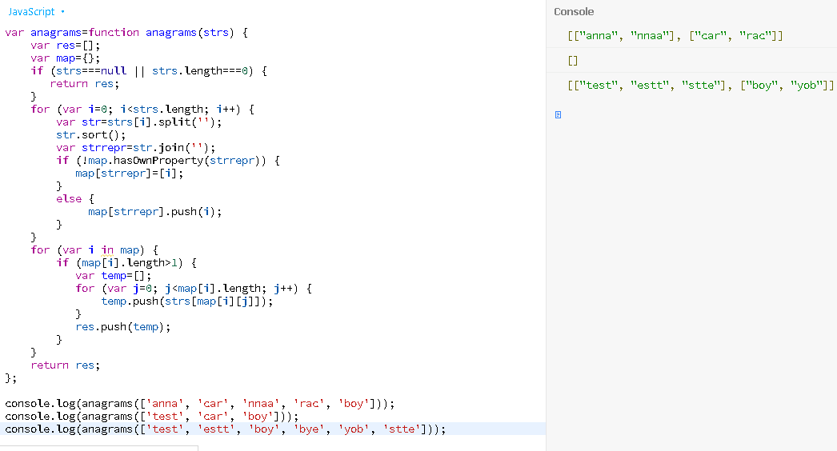

**102.Binary search**

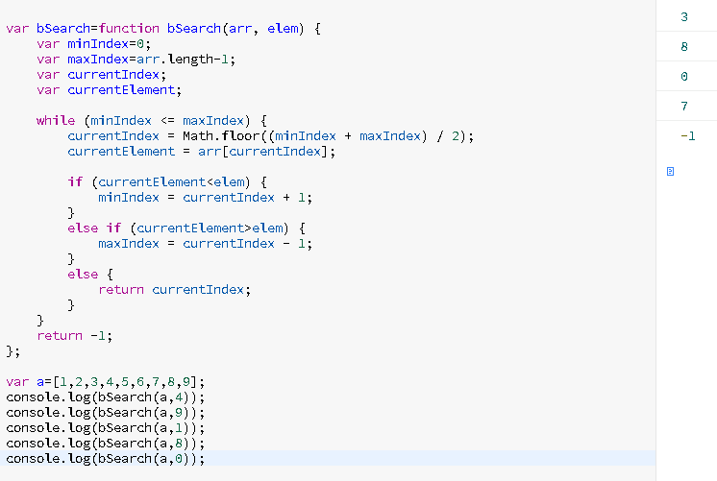

**103.**[**countAndSay.js**](https://github.com/izavits/js-practice/blob/master/src/countAndSay.js) **- Given an integer *n*, generate the *nth* sequence (1,11,21,1211,...)**

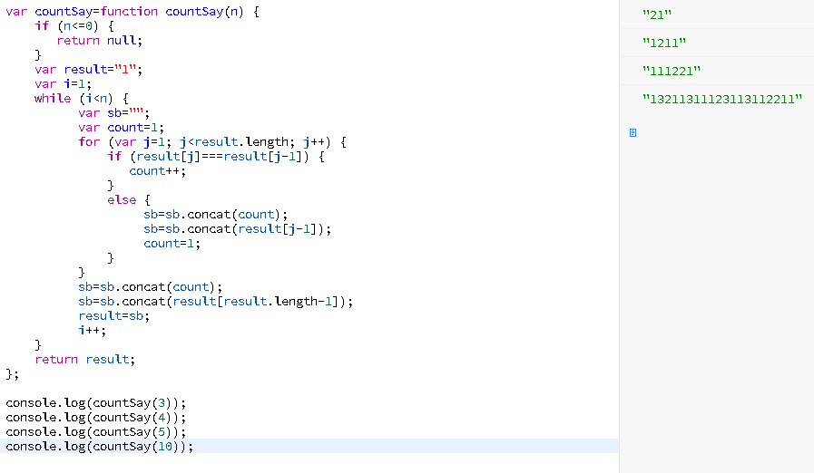

**104.Evaluate an expression**

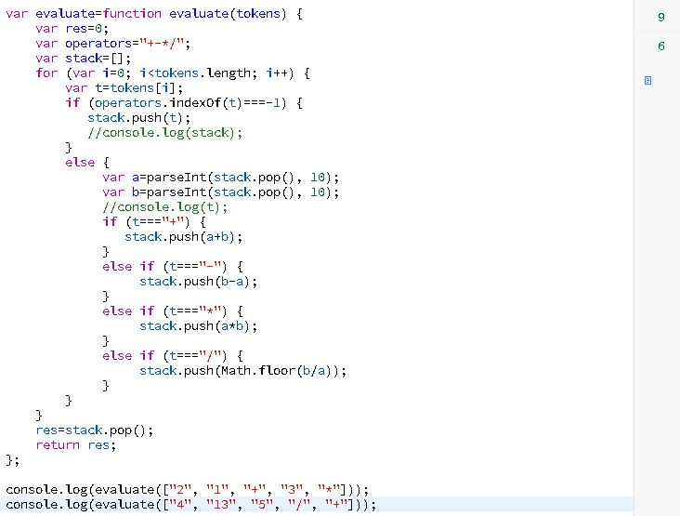

**105.Isomorphic**

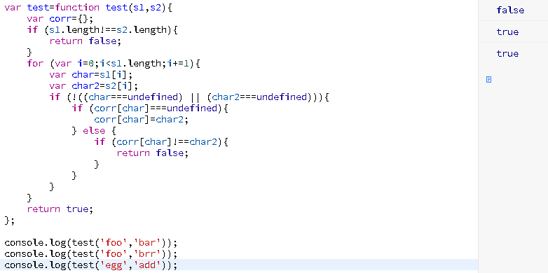

**106.Palindrome**

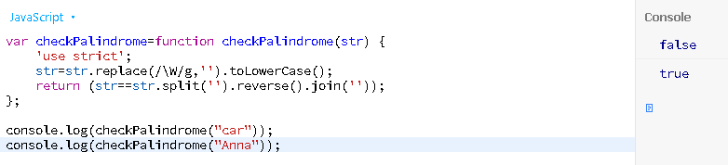

**107.Factorial**

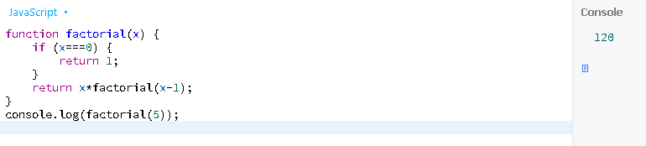

**108.Find greater common divisor of two positive numbers**

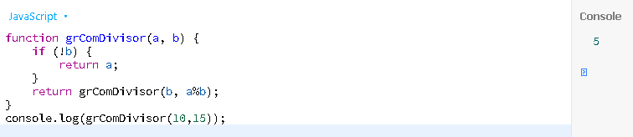

**109.Get the integers between a given range**

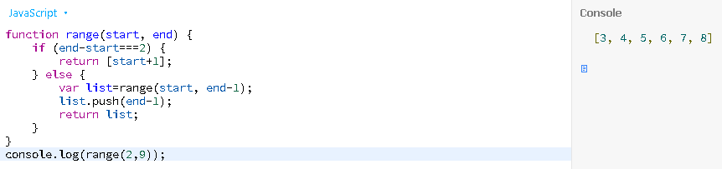

**110.Compute the exponent of a number**

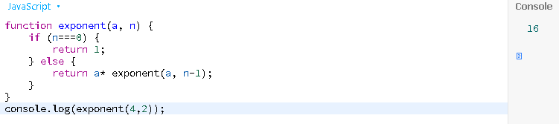

**111.Check if number is even**

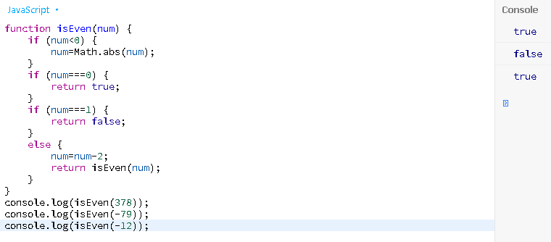

**112. Given an array and a value, remove all instances of that value in place and return the new length**

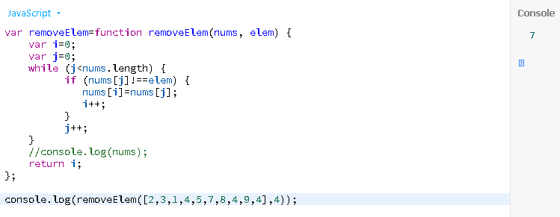

**113. Given an array and a value, remove all instances of that value in place and return the new length**

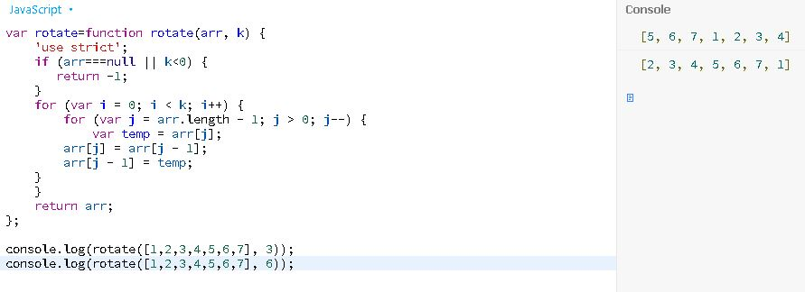

**114.Using the call method**

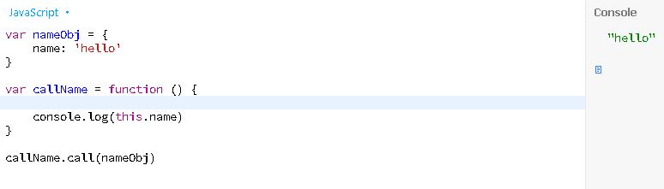

**115.Highest & Lowest Value (sorted)**

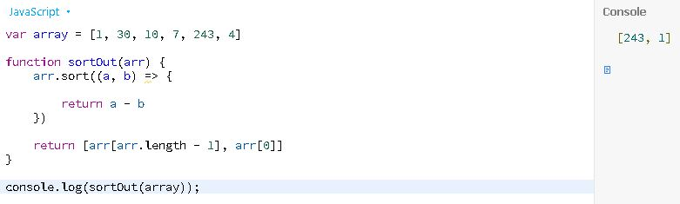

**116.Searching for Differences in Arrays**

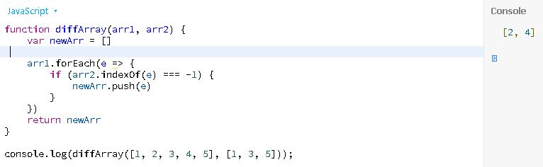

**117.function reverseString**

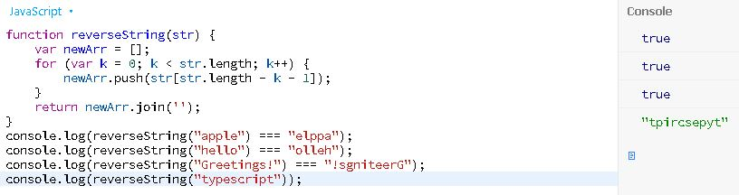

**118.reverseInteger**

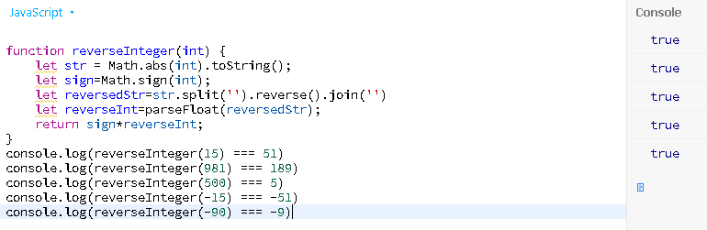

**119.Sum**

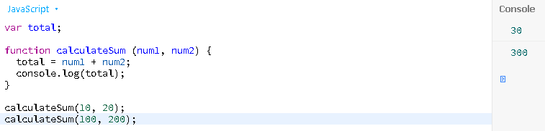

**120.For…loop**

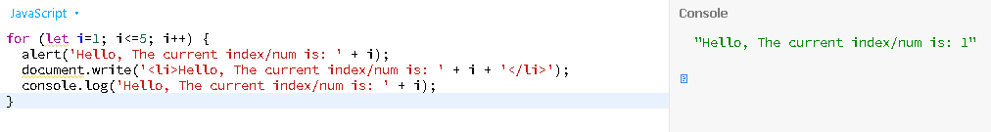

**121.For…loop reverse**

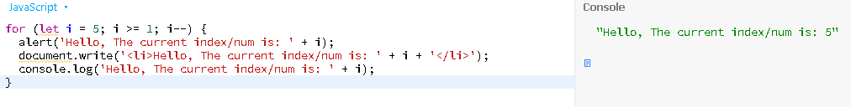

**122.For…loop even**

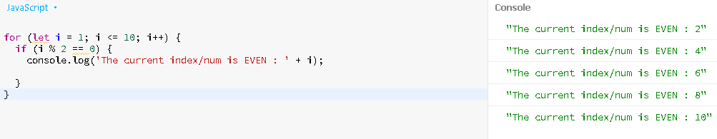

**123.While…loop**

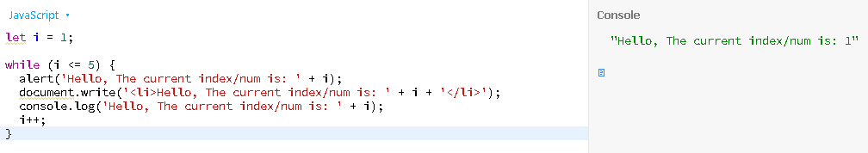

**124.do...while loop**

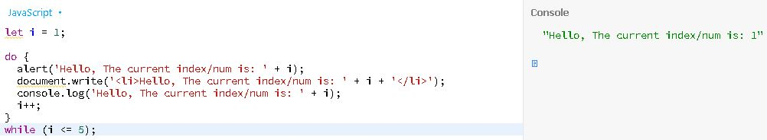

**125.The for...in loop**

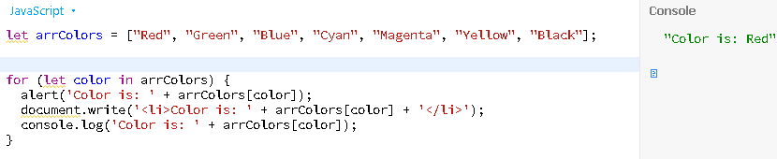

**126.for...in loop**

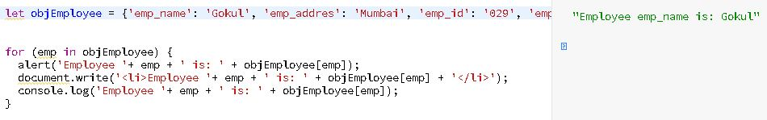

**127.for...of loop**

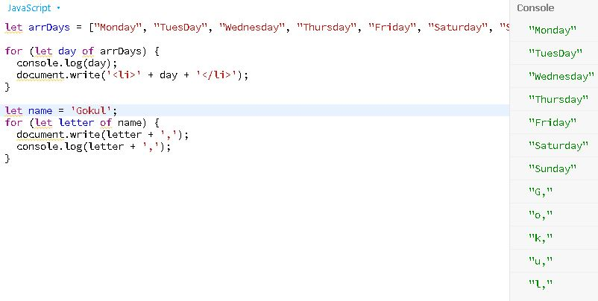

**128.Break**

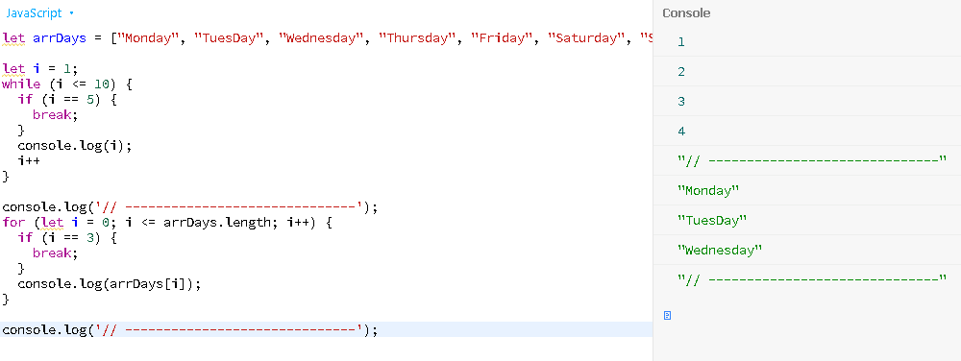

**129.Continue**

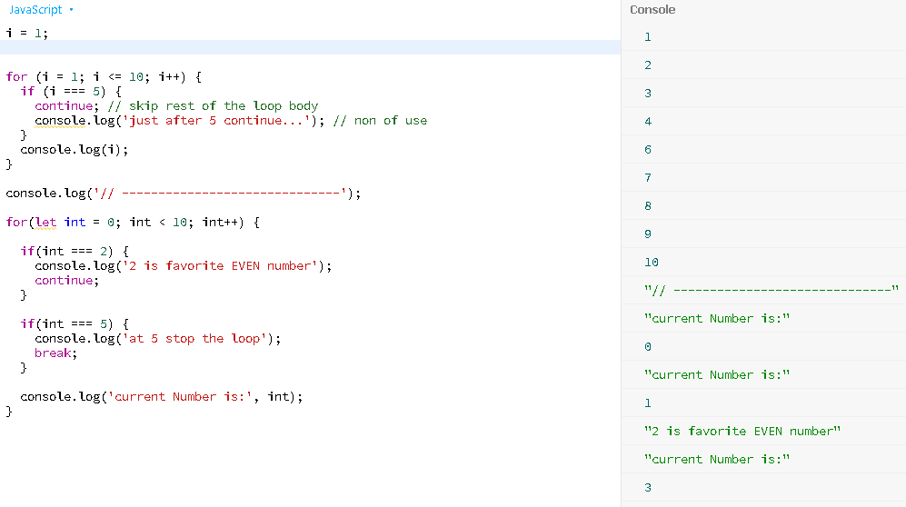

**130.Simple If**

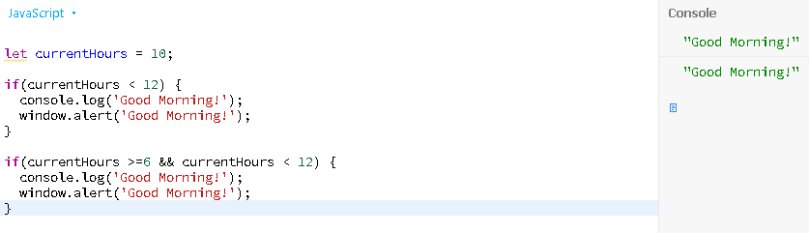

**131.Switch case**

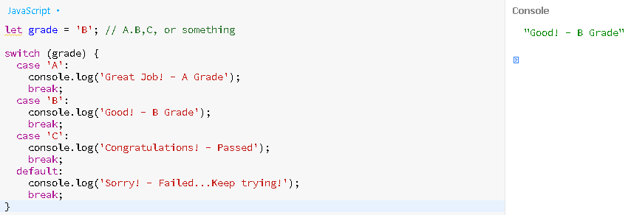

**132.Switch…case**

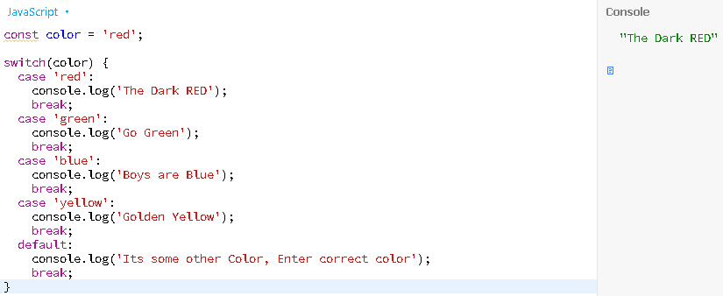

**133.Array.length**

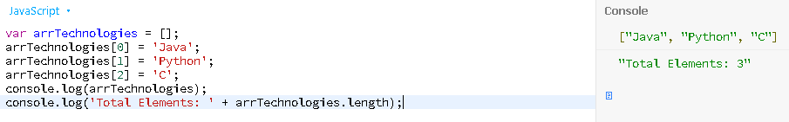

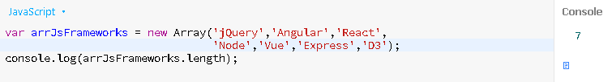

**134.Array using for loop**

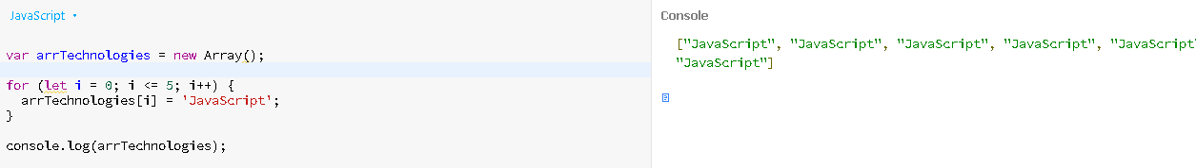

**135.isArray()**

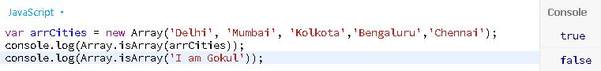

**136.indexOf() - get index/location of provided value**

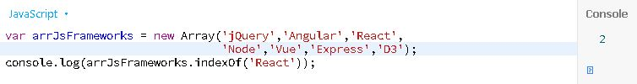

**137.object with properties**

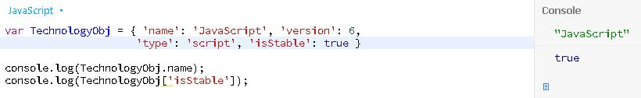

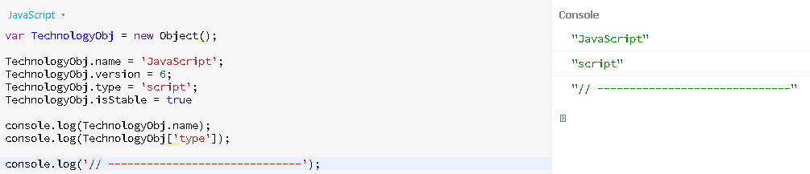

**138.delete MyObject.propertyName;**

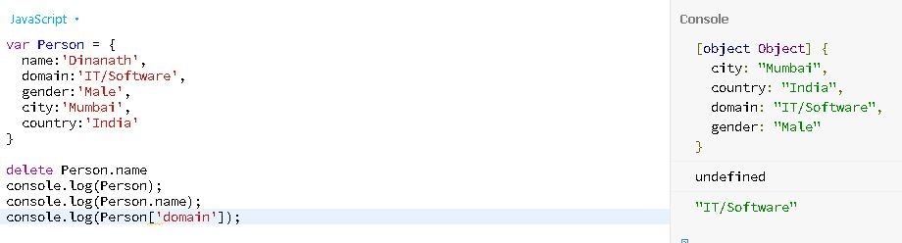

**139.The Math Object**

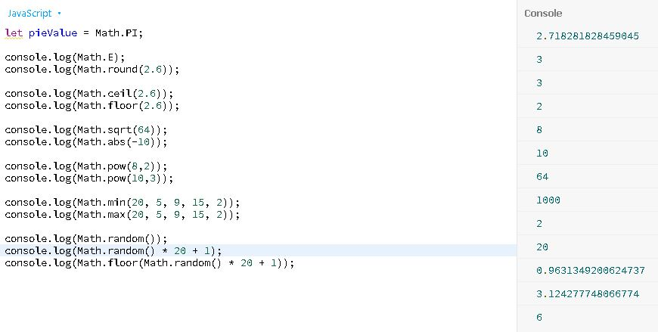

**140.Number to String conversion**

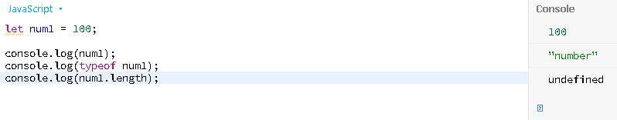

**141.Boolean to String conversion**

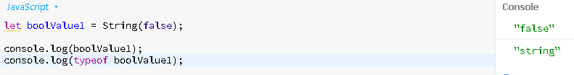

**142.Arithmetic operators**

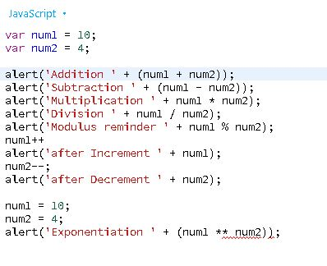

**143.Logical operators**

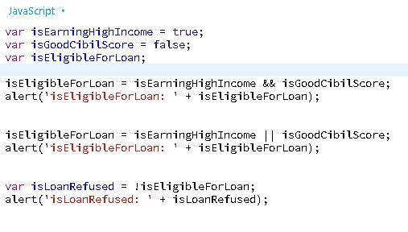

**144.Conditional (? or ternary) Operator**

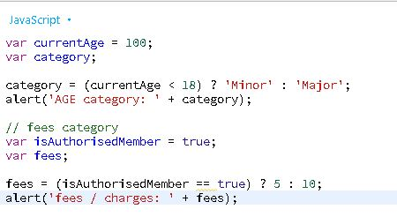

**145.pop()**

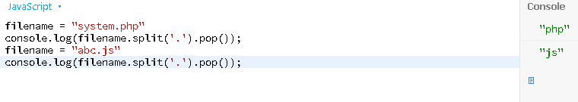

**146.sumTriple()**

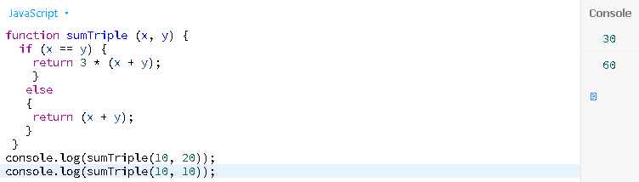

**147.Write a JavaScript program to check from two given integers, whether one is positive and another one is negative**

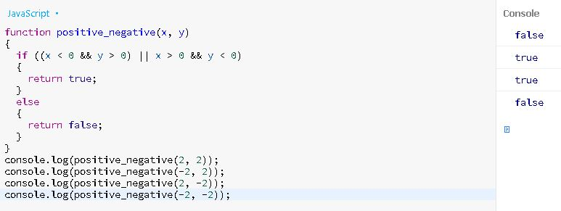

**148.Write a JavaScript program to create a new string adding "Py" in front of a given string. If the given string begins with "Py" then return the original string**

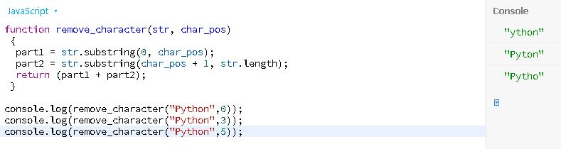

**149. Write a JavaScript program to create a new string from a given string with the first character of the given string added at the front and back**

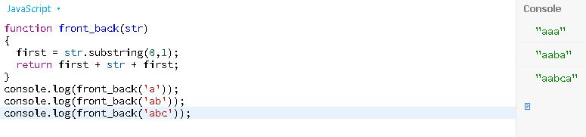

**150.Write a JavaScript program to find the largest of three given integers**

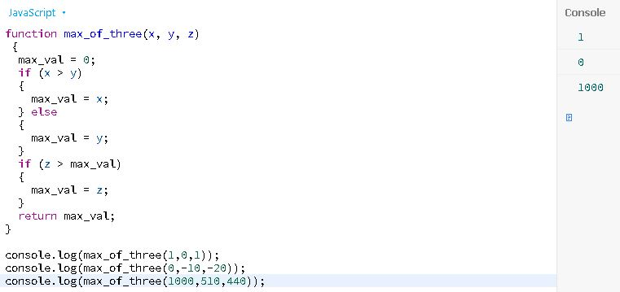

**151.Check whether all the digits in a given number are the same or not**

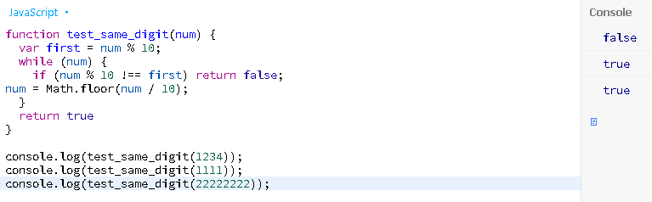

**152. Find the number of elements which presents in both of the given arrays**

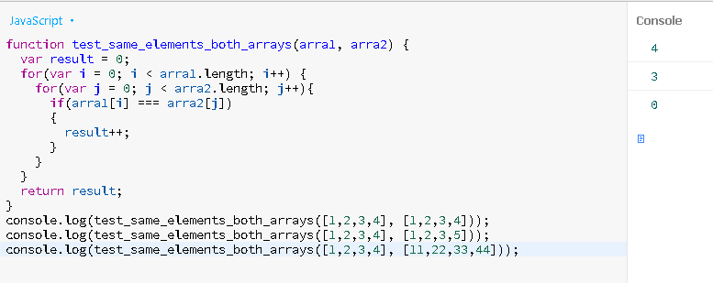

**153.Test whether a given integer is greater than 15 return the given number, otherwise return 15**

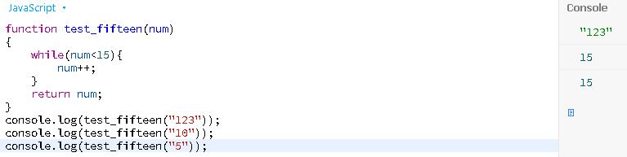

**154.Replace the first digit in a string (should contains at least digit) with $ character**

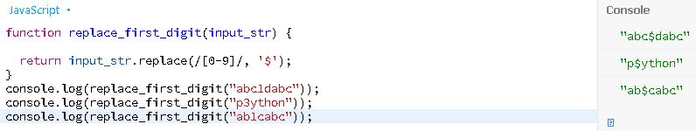

**155.Remove all characters from a given string that appear more than once**

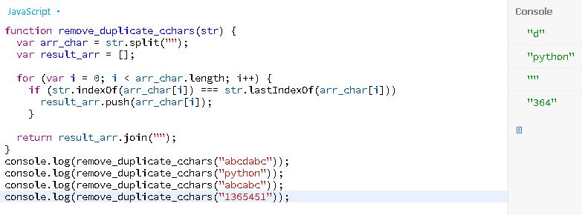

**156. Find the number of even digits in a given integer**

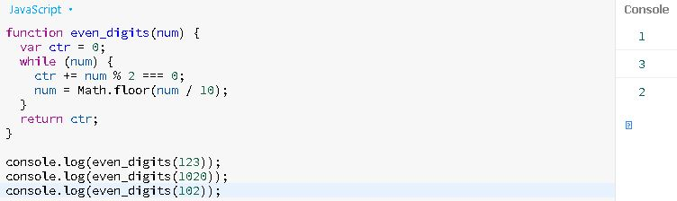

**157. Get the largest even number from an array of integers**

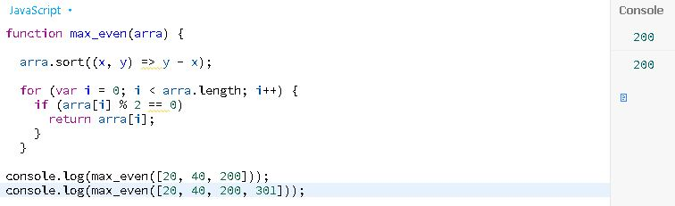

**158. Find the longest string from a given array**

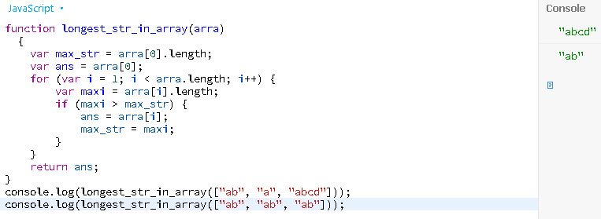

**159.Check whether a given number is in a given range**

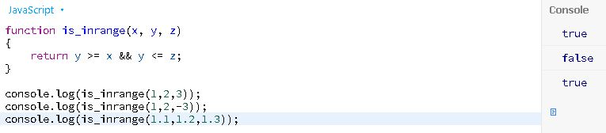

**160. Replace all the numbers with a specified number of a given array of integers**

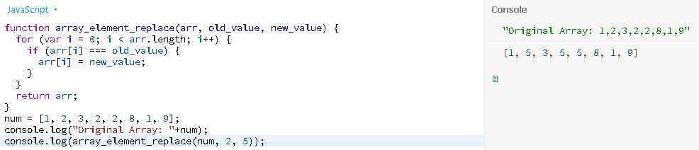

**161.Reverse the elements of a given array of integers length 3**

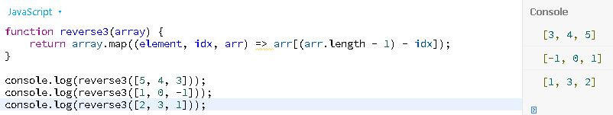

**162.Get a random element from an array**



**163.Create a shallow clone of an object**

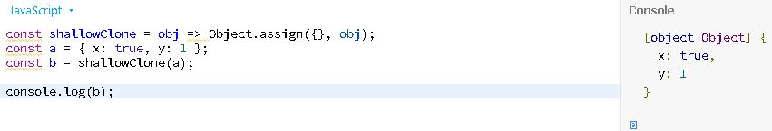

**164.Get an array of elements that appear in both arrays**

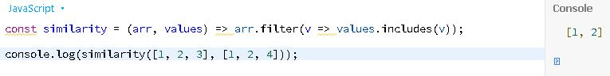

**165. Get an array of elements that appear in both arrays**

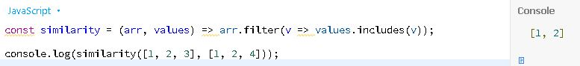

**166.Sort the characters of a string Alphabetically**

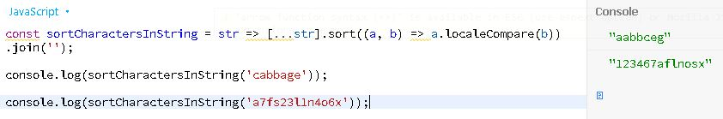

**167. Get an array with n elements removed from the beginning from a given array**

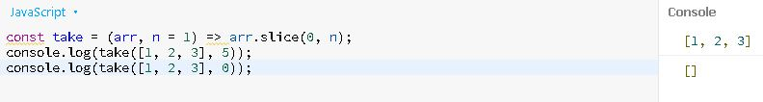

**168. Remove n elements from the end of a given array**

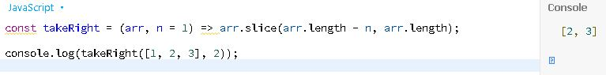

**169.Convert a value to a safe integer**

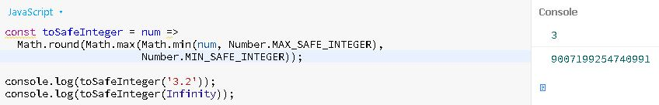

**170.Truncate a string up to a specified length**

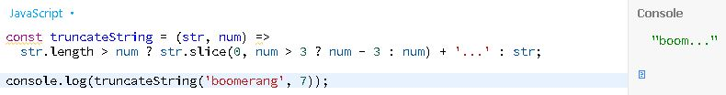

**171.Create a function that accepts up to one argument, ignoring any additional arguments**

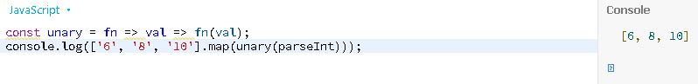

**172. Get every element that exists in any of the two arrays once**

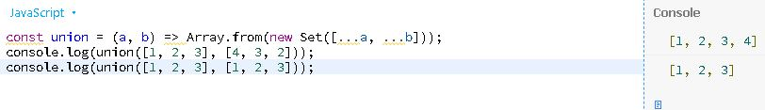

**173. Return true if the given value is a number, false otherwise**

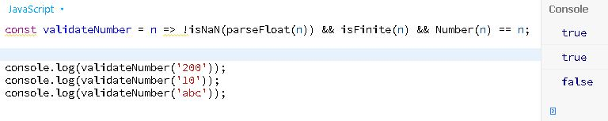

**174. Remove falsey values from a given array**

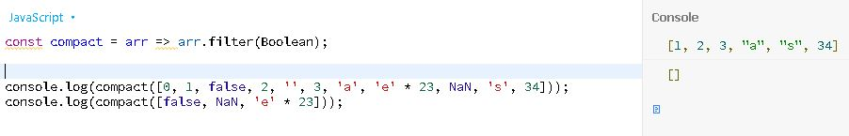

**175.Get a random integer in the specified range**

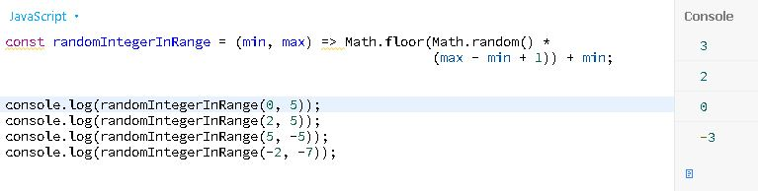

**176.Get a random number in the specified range**

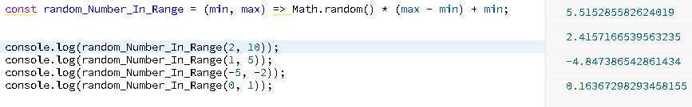

**177.Filter out the element(s) of a given array, that have one of the specified values**

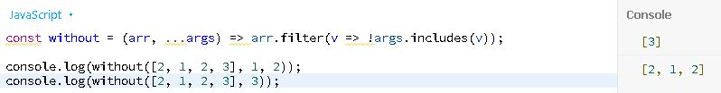

**178.Calculate the factorial of a number**

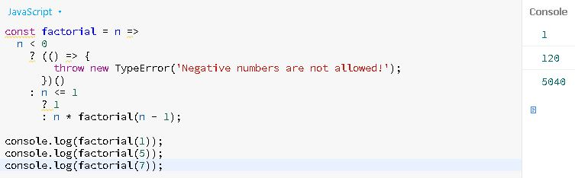

**179.Check if the given number falls within the given range**

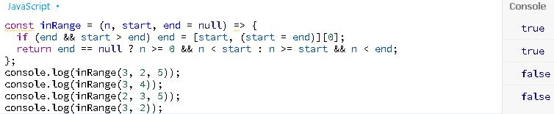

**180.Get all the elements of an array except the last one**

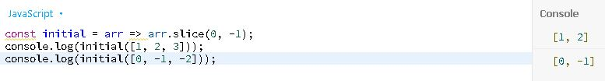

**181.Check whether the given argument is a native boolean element**

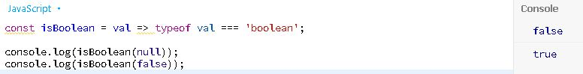

**182.Check if a given number is even or not**

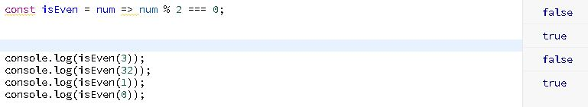

**183.Check whether the given argument is a function**

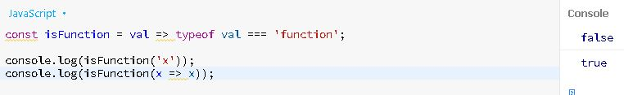

**184. Check whether a string is lower case or not**

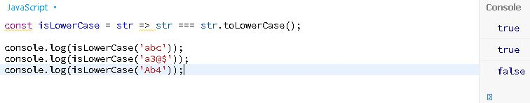

**185.Check if a given argument is a number**

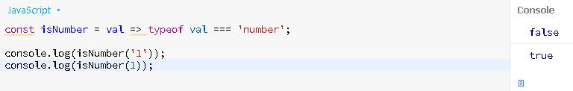

**186. Check whether the given argument is a string**

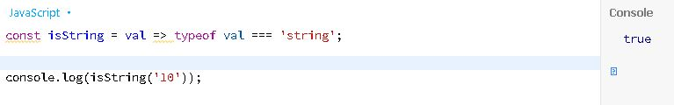

**187. Check whether the given argument is a symbol**

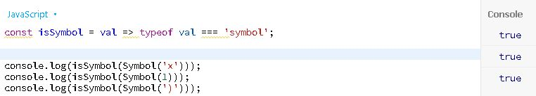

**188. Get the last element from a given array**

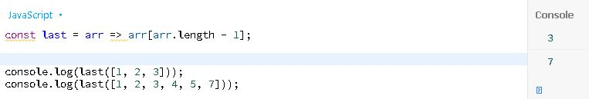

**189. Takes a predicate and array, like Array.filter(), but only keeps x if pred(x) returns false**

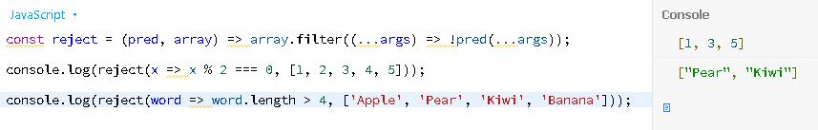

**190.Pass a JavaScript function as parameter**

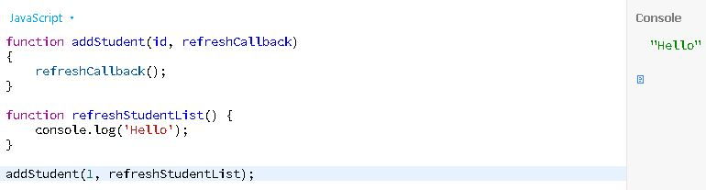

**191. Bigger elements in an array**

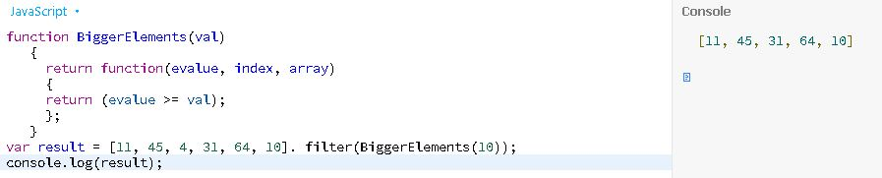

**192.Compute the sum of an array of integers**

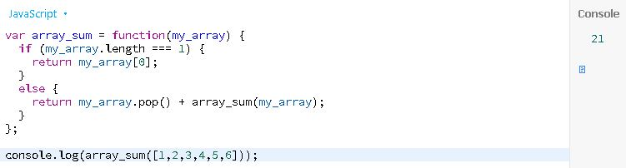

**193. Sum the multiples of 3 and 5 under 1000**

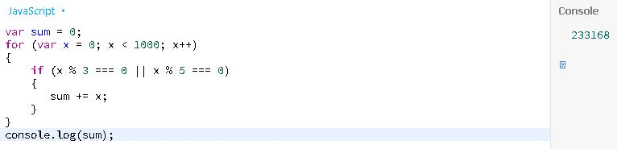

**194. Accept two integers and display the larger**

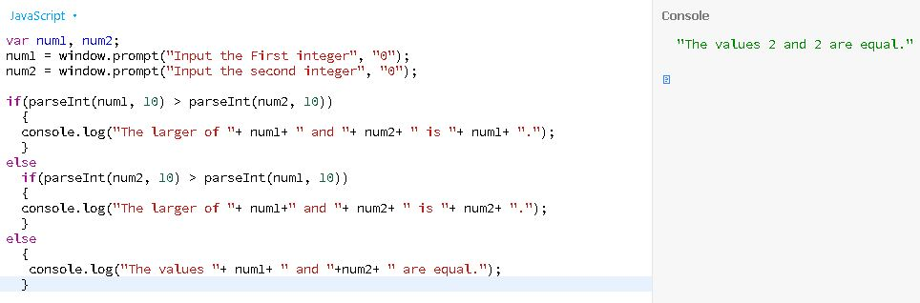

**195.Find the sign of product of three numbers**

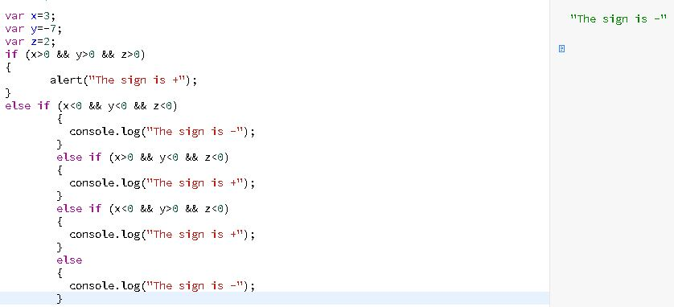

**196. How to sort three numbers**

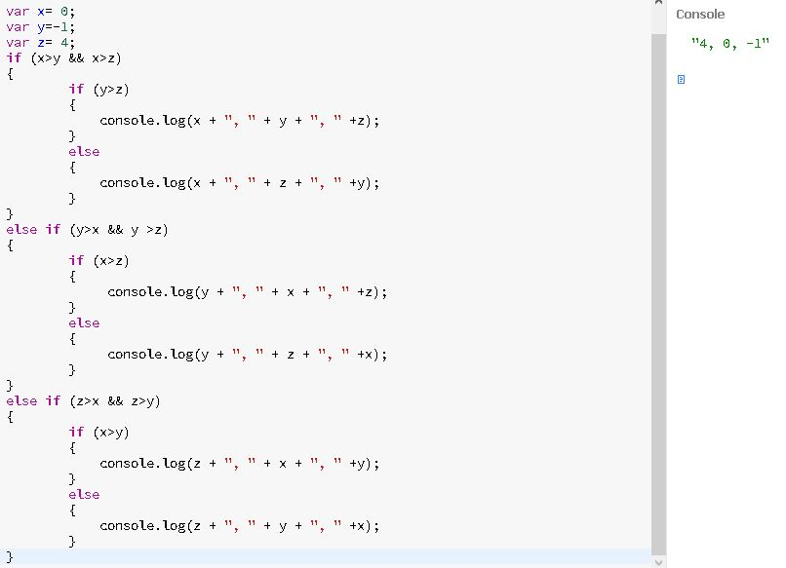

**197.Find the largest of five numbers**

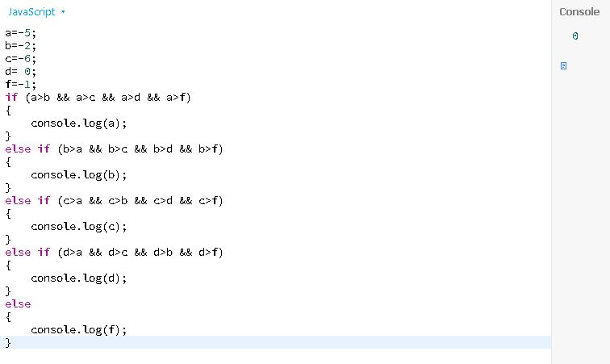

**198.For loop that will iterate from 0 to 15 to find even and odd numbers**

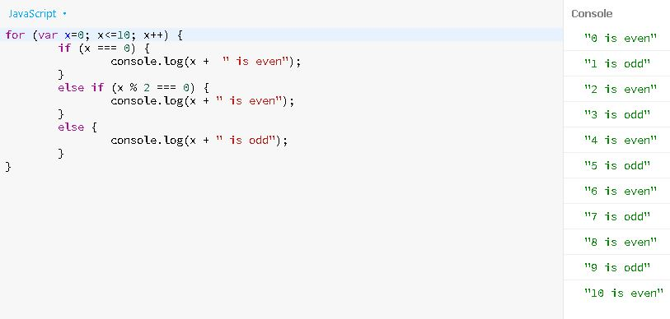

**199.Cast a square root of a number to an integer**

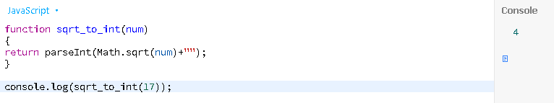

**200.Count the digits of an integer**

